A Group Project Report on

**OLD PHOTO RESTORATION USING DEEP LATENT SPACE TRANSLATION**

Submitted to

The Department of Computer Science and Engineering

In partial fulfillment of the academic requirements of

Jawaharlal Nehru Technological University

For

The award of the degree of

Bachelor of Technology

in

Computer Science and Engineering

(2018 – 2022)

By

G.KAVYA 18311A05T3

CHITYALA UDHAY 18311A05R4

RISHABH SEMWAL 18311A05W2

Under the Guidance of

Dr.K.Basavaraju (Associate Professor)



Sreenidhi Institute of Science and Technology

Yamnampet, Ghatkesar, R.R. District, Hyderabad - 501301

Affiliated to

Jawaharlal Nehru Technology University

Hyderabad - 500085

Department of Computer Science and Engineering

Sreenidhi Institute of Science and Technology



**CERTIFICATE**

This is to certify that this Group Project report on “**OLD PHOTO RESTORATION USING DEEP LATENT SPACE TRANSLATION**”, submitted by G.KAVYA(18311A05T3), CHITYALA UDHAY(18311A05R4),RISHABH SEMWAL(18311A05W2) in the year 2021 in partial fulfillment of the academic requirements of Jawaharlal Nehru Technological University for the award of the degree of Bachelor of Technology in Computer Science and Engineering, is a bonafide work that has been carried out by them as part of their **Group Project during Third Year Second Semester** , under our guidance. This report has not been submitted to any other institute or university for the award of any degree.

Dr.K.Basavaraju Dr . Aruna Varanasi

Associate Professor Head, Department of CSE

Department of CSE

Internal Guide

External Examiner

Date:-

**DECLARATION**

We, **G.Kavya (18311A05T3), Chityala Udhay(18311A05R4) and Rishabh Semwal (18311A05W2),** students of **SREENIDHI INSTITUTE OF SCIENCE AND TECHNOLOGY, YAMNAMPET, GHATKESAR,** studying IIIrd year 2nd semester, **COMPUTER SCIENCE AND ENGINEERING** solemnly declare that the Group project work, titled **“Old Photo Restoration using Deep Latent Space Translation”** is submitted to **SREENIDHI INSTITUTE OF SCIENCE AND TECHNOLOGY** for partial fulfillment for the award of degree of Bachelor of technology in **COMPUTER SCIENCE AND ENGINEERING**.

It is declared to the best of our knowledge that the work reported does not form part of any dissertation submitted to any other University or Institute for award of any degree

**ACKNOWLEDGEMENT**

I would like to express my gratitude to all the people behind the screen who helped me to transform an idea into a real application.

I would like to express my heart-felt gratitude to my parents without whom I would not have been privileged to achieve and fulfill my dreams. I am grateful to our principal, **Dr. T. Ch. Siva Reddy,** who most ably run the institution and has had the major hand in enabling me to do my project.

I profoundly thank Dr. **ARUNA VARANASI**, Head of the Department of Computer Science & Engineering who has been an excellent guide and also a great source of inspiration to my work.

I would like to thank my internal guide **Dr.K.Basavaraju** for his/her technical guidance, constant encouragement and support in carrying out my project at college.

The satisfaction and euphoria that accompany the successful completion of the task would be great but incomplete without the mention of the people who made it possible with their constant guidance and encouragement crowns all the efforts with success. In this context, I would like thank all the other staff members, both teaching and non-teaching, who have extended their timely help and eased my task.

**G.Kavya 18311A05T3**

**chityala udhay 18311A05R4**

**rishabh semwal 18311A05W2**

**INDEX**

**List of Figures** i

**Abstract** iii

**1.INTRODUCTION** 1

1.1 Scope 2

1.2 Existing System 2

1.3 Proposed System 3

**2.SYSTEM ANALYSIS**  4

2.1 Functional Requirement Specifications 4

2.2 Performance Requirements 4

2.3 Software Requirements 5

2.4 Hardware Requirements 5

**3.SYSTEM DESIGN** 6

3.1 Architecture Design 7

3.2 Modules 7

3.3 UML Diagrams 8

3.3.1 Use Case Diagrams 9

3.3.2 Class Diagrams 10

3.3.3 Sequence Diagrams 11

3.3.4 Activity Diagrams 12

**4.SYSTEM IMPLEMENTATION** 13

**5.OUTPUT SCREENS** 18

**6.CONCLUSION AND FUTURE SCOPE** 22

**REFERENCES** 22

**Appendix-A:Python Programming** 23

**Appendix-B:Unified Modeling Language** 41

**DATA PREPROCESSING USING WEB INTERFACE**

**Abstract**

* Data Preprocessing for Data Mining addresses one of the most important issues within the well-known Knowledge Discovery from Data process. Data directly taken from the source will likely have inconsistencies, errors or most importantly, it is not ready to be considered for a data mining process. Furthermore, the increasing amount of data in recent science, industry and business applications, calls to the requirement of more complex tools to analyze it.
* The idea is to make one such tool that helps in preprocessing the data as per the user convenience with a proper and comprehensive set of functions and to preprocess the data with a interactice web interface.
* Real-world data is often noisy, incomplete with missing entries, and more often than not unsuitable for direct use for building models or solving complex data-related problems. There might be erroneous data, or the data might be unordered, unstructured, and unformatted.
* The above reasons render the collected data unusable for machine learning purposes. It’s seen that the same data when formatted and cleaned produces more accurate and reliable results when used by machine learning models other than their unprocessed counterparts.
* This tool helps the user to preprocess the data with the functionalities of data cleaning, data transformation, data inspection, data encoding, splitting the data etc…

**1.INTRODUCTION**

Photos are taken to freeze the happy moments that otherwise gone. Even though time goes by, one can still evoke memories of the past by viewing them. Nonetheless, old photo prints deteriorate when kept in poor environmental condition, which causes the valuable photo content permanently damaged. Fortunately, as mobile cameras and scanners become more accessible, people can now digitalize the photos and invite a skilled specialist for restoration. However, manual retouching is usually laborious and time consuming, which leaves piles of old photos impossible to get restored.

Hence, it is appealing to design automatic algorithms that can instantly repair old photos for those who wish to bring old photos back to life. Prior to the deep learning era, there are some attempts that restore photos by automatically detecting the localized defects such as scratches and blemishes, and filling in the damaged areas with inpainting techniques. Yet these methods focus on completing the missing content and none of them can repair the spatially-uniform defects such as film grain, sepia effect, color fading, etc., so the photos after restoration still appear outdated compared to modern photographic images. With the emergence of deep learning, one can address a variety of low-level image restoration problems by exploiting the powerful representation capability of convolutional neural networks, i.e., learning the mapping for a specific task from a large amount of synthetic images.

The same framework, however, does not apply to old photo restoration and the reason is three-fold. First, the degradation process of old photos is rather complex, and there exists no degradation model that can realistically render the old photo artifact. Therefore, the model learned from those synthetic data generalizes poorly on real photos. Second, old photos are plagued with a compound of degradation and inherently require different strategies for repair: unstructured defects that are spatially homogeneous, e.g., film grain and color fading, should be restored by utilizing the pixels in the neighborhood, whereas the structured defects, e.g., scratches, dust spots, etc., should be repaired with a global image context. Furthermore, people are fastidious to tiny artifacts around faces yet a network trained on general natural images cannot capture facial intrinsic characteristics.

**1.1 SCOPE:**

A network targeting for face retouching is needed especially considering portraits account for large proportion of old photos. To circumvent these issues, we formulate the old photo restoration as a triplet domain translation problem. Different from previous image translation methods , we leverage data from three domains (i.e., real old photos, synthetic images and the corresponding ground truth), and the translation is performed in latent space. Synthetic images and the real photos are first transformed to the same latent space with a shared variational autoencoder (VAE). Meanwhile, another VAE is trained to project ground truth clean images into the corresponding latent space.

The mapping between the two latent spaces is then learned with the synthetic image pairs, which restores the corrupted images to clean ones. The advantage of the latent restoration is that the learned latent restoration can generalize well to real photos because of the domain alignment within the first VAE. Besides, we differentiate the mixed degradation and propose a partial nonlocal block that considers the long range dependencies of latent features to specifically address the structured defects during the latent translation.

Finally, considering that faces are the most important visual stimuli, we propose a post-processing step with a coarse-to-fine generator to reconstruct high-resolution faces with hierarchical spatial adaptive conditions.In comparison with several leading restoration methods, we prove the effectiveness of our approach in restoring multiple degradations of real photos.

**1.2 EXISTING SYSTEM:**

Existing image degradation can be roughly categorized into two groups: unstructured degradation such as noise, blurriness, color fading, and low resolution, and structured degradation such as holes, scratches, and spots.

For the former unstructured ones, traditional works often impose different image priors, including nonlocal self-similarity sparsity and local smoothness.

**DISADVATNAGE:**

* Compared to unstructured degradation, structured degradation is more challenging and often modeled as the “image painting” problem.
* Can’t repair the defects such as film grain, sepia effect, color fading, etc., so the photos after restoration still appear outdated compared to modern photographic images.

**1.3 PROPOSED SYSTEM:**

In this work, we aim to restore in-the-wild faces with well-preserved identity while caring for robustness. To this end, we do not rely on face prior and learn the restoration by synthesis: instead of letting the network digest the degraded faces as input.

The output is synthesized from a latent noise with the latent features modulated by the degraded faces through spatially variant de-normalization.

**ADVANTAGE:**

* We will show that this approach achieves preferable quality in restoring vintage portraits.
* The proposed pipeline demonstrates superior performance over state-of-the-art methods as well as existing commercial tools in terms of visual quality for old photos restoration.

**2.SYSTEM ANALYSIS**

**2.1 Functional Requirement Specification**

The System after careful analysis has been identified to be present with the following modules.

Data Extraction:

Importing the libraries and requirements, training the models with the dataset containing images (real and synthetic) and create the code to test the images for the restoration.

Deep Latent Space:

We formulate the old photo restoration as an image translation problem, where we treat clean images and old photos as images from distinct domains and we wish to learn the mapping in between. However, as opposed to general image translation methods that bridge two different domains, we translate images across three domains: the real photo domain , the synthetic domain where images suffer from artificial degradation, and the corresponding ground truth domain that comprises images without degradation. Such triplet domain translation is crucial in our task as it leverages the unlabeled real photos as well as a large amount of synthetic data associated with ground truth.

Results Evaluation:

Test the model or can use the pre-trained models,provide the input images and evaluate the results of the restored images.

**2.2. Performance Requirements**

Performance is measured in terms of the output provided by the application. Requirement specification plays an important part in the analysis of a system. Only when the requirement specifications are properly given, it is possible to design a system, which will fit into required environment. It rests largely with the users of the existing system to give the requirement specifications because they are the people who finally use the system. This is because the requirements have to be known during the initial stages so that the system can be designed according to those requirements. It is very difficult to change the system once it has been designed and on the other hand designing a system, which does not cater to the requirements of the user, is of no use.

The requirement specification for any system can be broadly stated as given below:

* The system should be able to interface with the existing system
* The system should be accurate
* The system should be better than the existing system

The existing system is completely dependent on the user to perform all the duties.

**2.3 Software Requirements**

Operating System : Windows 10

Language : Python 3.7

Google(or any browser)

Text editor :Google Colab.

**2.4 Hardware Requirements**

Processor : Intel I5

Graphic Card:Nvidia GeForce 4GB

RAM :8GB

Hard disk : 250 GB

|  |  |  |
| --- | --- | --- |
| **Processor** | **:** | **Intel** |
| RAM | : | 8GB |
| Hard disk | : | 250GB |

**3.SYSTEM DESIGN:**

The System Design Document describes the system requirements, operating environment, system and subsystem architecture, files and database design, input formats, output layouts, human-machine interfaces, detailed design, processing logic, and external interfaces.

This section describes the system in narrative form using non-technical terms. It should provide a high-level system architecture diagram showing a subsystem breakout of the system, if applicable. The high-level system architecture or subsystem diagrams should, if applicable, show interfaces to external systems. Supply a high-level context diagram for the system and subsystems, if applicable. Refer to the requirements trace ability matrix (RTM) in the Functional Requirements Document (FRD), to identify the allocation of the functional requirements into this design document.

This section describes any constraints in the system design (reference any trade-off analyses conducted such, as resource use versus productivity, or conflicts with other systems) and includes any assumptions made by the project team in developing the system design.

The organization code and title of the key points of contact (and alternates if appropriate) for the information system development effort. These points of contact should include the Project Manager, System Proponent, User Organization, Quality Assurance (QA) Manager, Security Manager, and Configuration Manager, as appropriate.

**3.1SystemArchitecture**



**3.2 Modules**

* **Data Extraction**
* **Deep Latent Space Translation**
* **Results Evaluation**

Data Extraction:

Importing the libraries and requirements, training the models with the dataset containing images (real and synthetic) and create the code to test the images for the restoration.

Deep Latent Space:

We formulate the old photo restoration as an image translation problem, where we treat clean images and old photos as images from distinct domains and we wish to learn the mapping in between. However, as opposed to general image translation methods that bridge two different domains, we translate images across three domains: the real photo domain , the synthetic domain where images suffer from artificial degradation, and the corresponding ground truth domain that comprises images without degradation. Such triplet domain translation is crucial in our task as it leverages the unlabeled real photos as well as a large amount of synthetic data associated with ground truth.

Results Evaluation:

Test the model or can use the pre-trained models,provide the input images and evaluate the results of the restored images.

**3.3 UML Diagrams**

UML (Unified Modeling Language) is a standard vernacular for choosing, envisioning, making, and specifying the collectibles of programming structures. UML is a pictorial vernacular used to make programming blue prints. It is in like way used to exhibit non programming structures similarly like process stream in a gathering unit and so forth.

UML is not a programming vernacular yet rather instruments can be utilized to make code in different tongues utilizing UML graphs. UML has an incite relationship with question composed examination and outline. UML expect a fundamental part in portraying trade viewpoints of a structure.

**Use case Diagram:**

The use case graph is for demonstrating the direct of the structure. This chart contains the course of action of use cases, performing pros and their relationship. This chart might be utilized to address the static perspective of the structure.

**Use Case Diagram:**

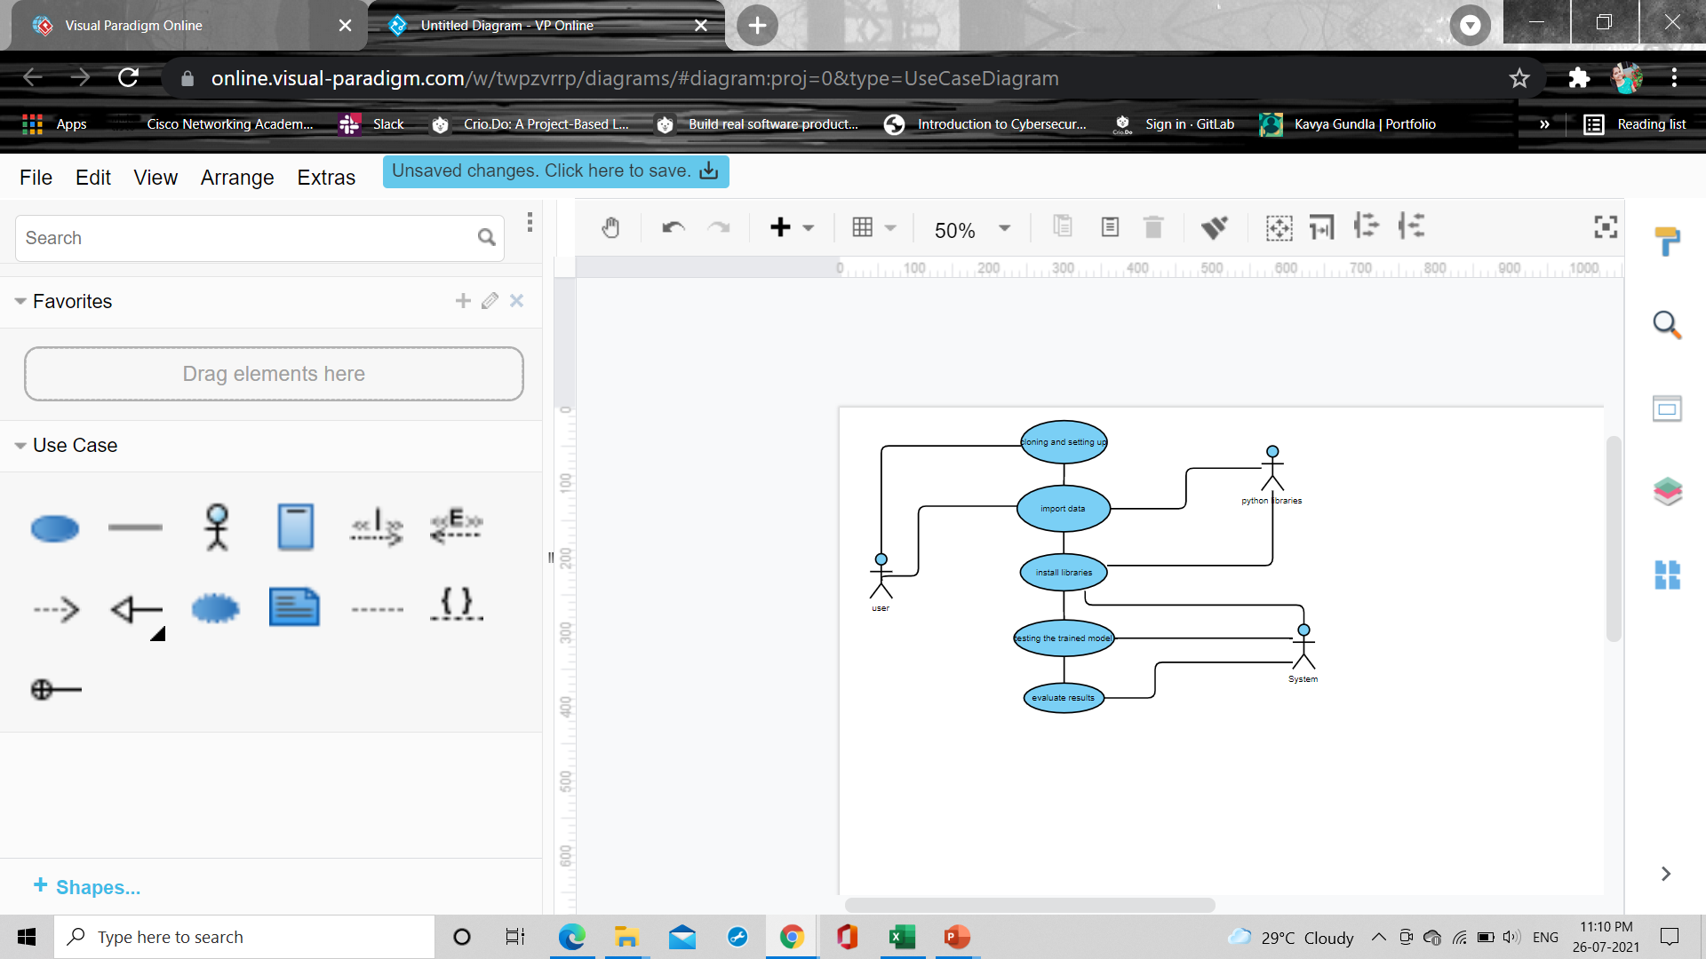

In the above diagram, the user import the data and do data extraction,the actor python libraries install and import required libraries,which are useful for extracting features by user,next the user divide the data into train or can use the pretrained model and test and both user and system trains the model,then system fits the data to model test the model and finally evaluate the results.

**Class Diagram:**

The class graph is the most normally pulled in layout UML. It addresses the static course of action perspective of the structure. It solidifies the strategy of classes, interfaces, joint attempts and their affiliations.

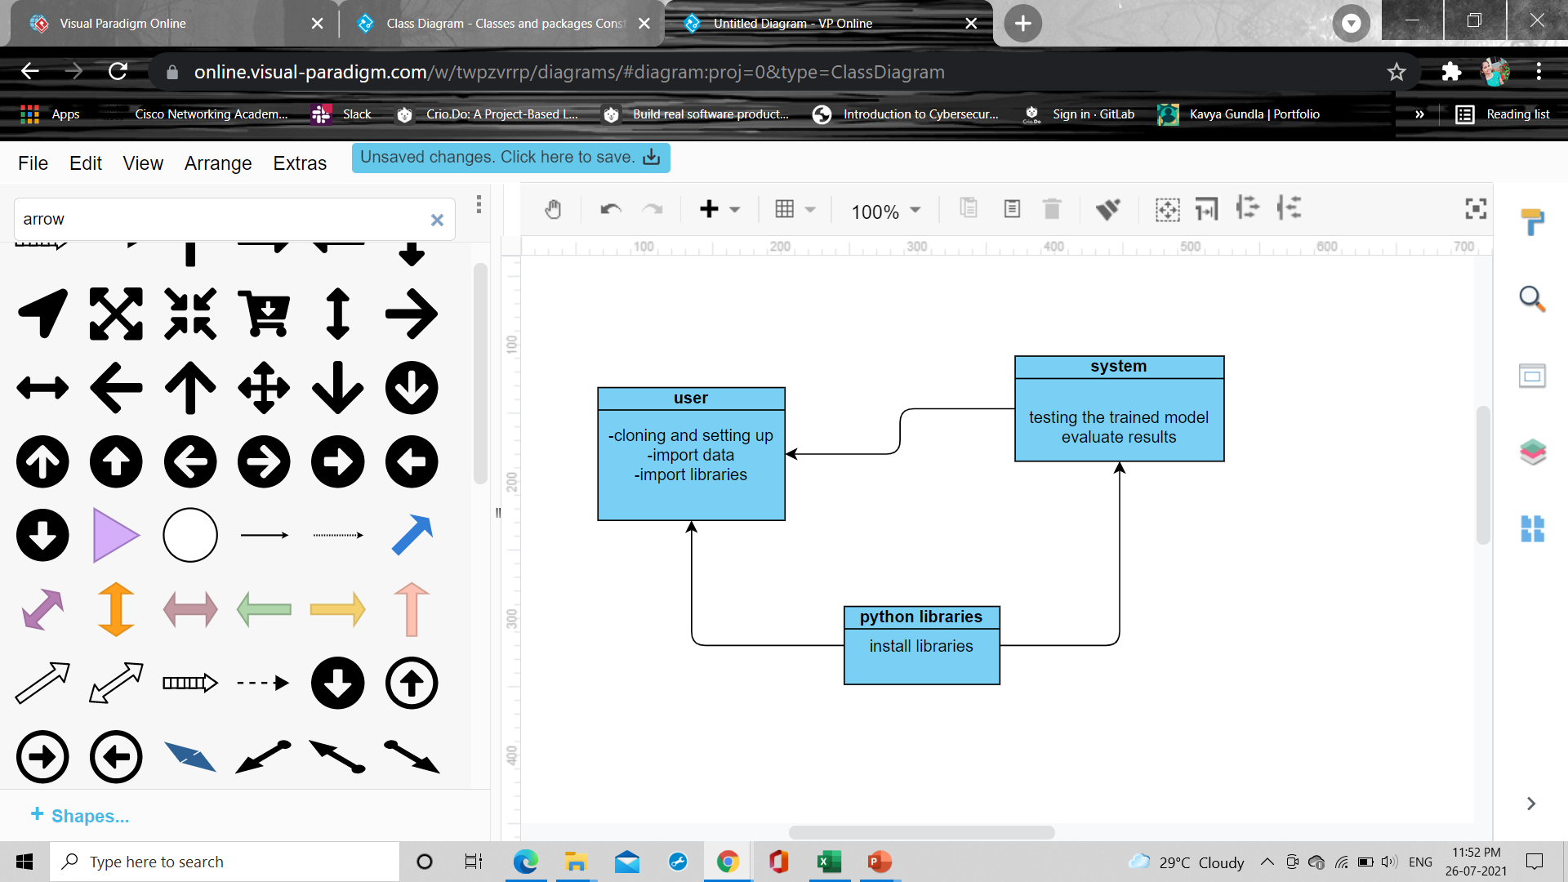

In the above class diagram, the relationship that is the dependence between each one of the classes is sketched out. Additionally, even the operations performed in each and every class is similarly appeared.

**Sequence Diagram:**

This is a cooperation design which tends to the time requesting of messages. It includes set of parts and the messages sent and gotten by the instance of parts. This chart is utilized to address the dynamic perspective of the structure.

A succession outline indicates question communications masterminded in time arrangement. In the below graph, there are three articles cooperating with each other. Each protest has a vertical dashed line which speaks to the presence of a question over some undefined time frame. This graph has additionally a tall, thin rectangle which is called center of control that demonstrates the timeframe amid which a protest is playing out an activity, either specifically or through a subordinate system.

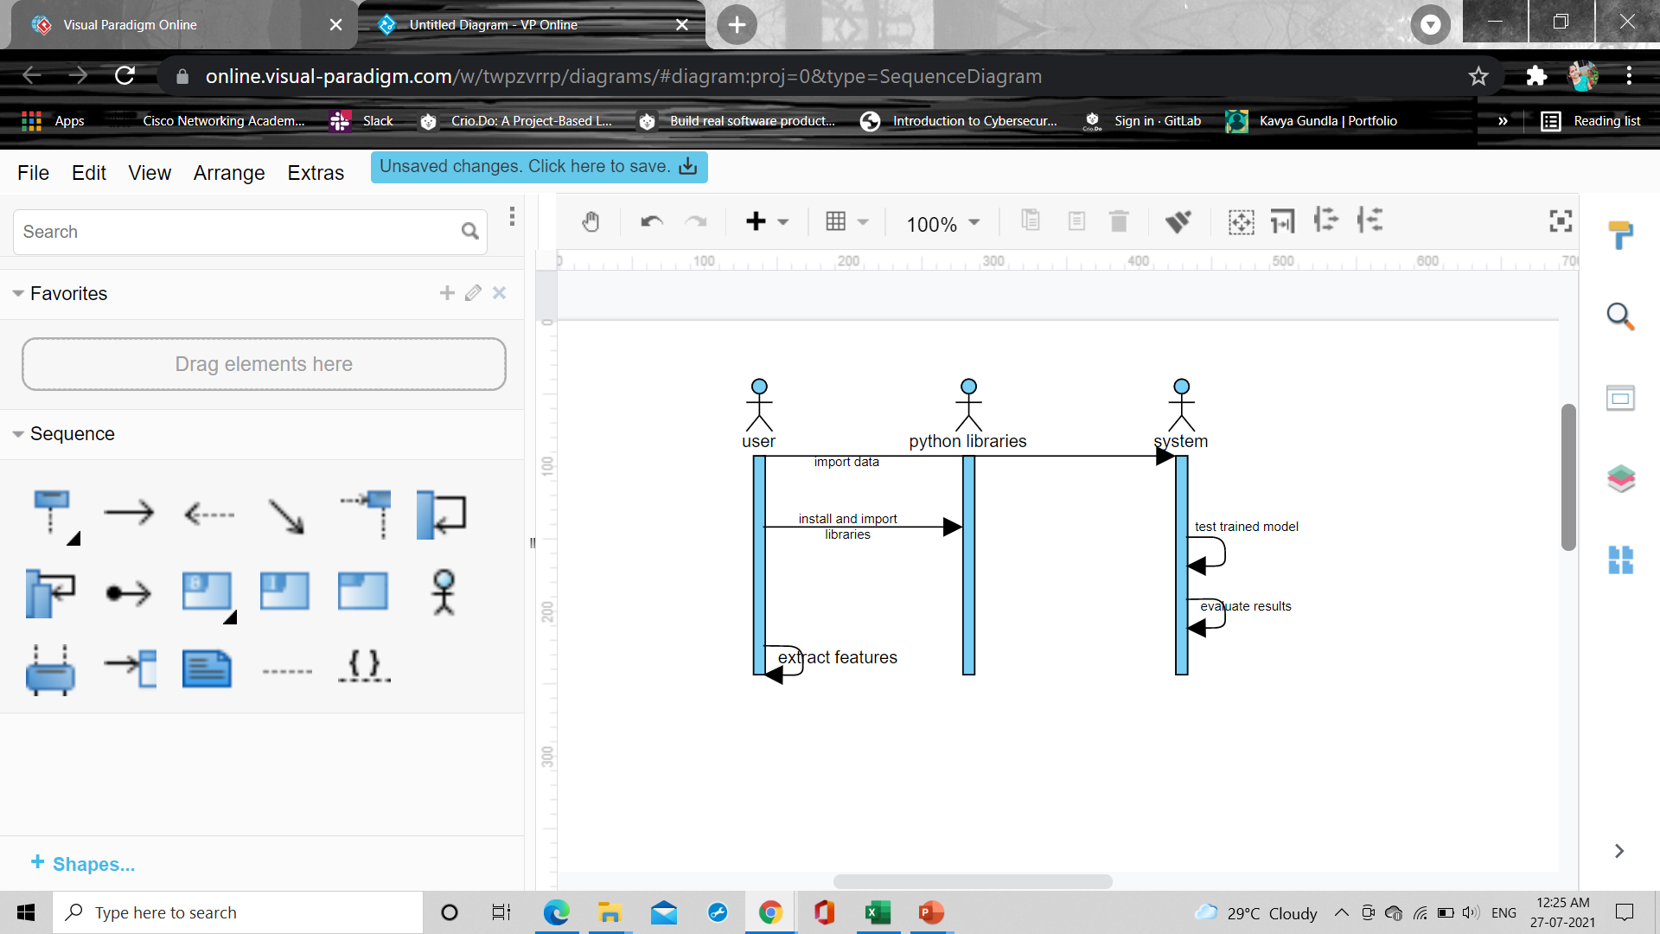

**Activity Diagram**:

An Activity in the activity diagram is also known as Activity state. It is used to represent the invocation of operation, a step in an entire business process. Swimlane is a way in which the performed activities can be grouped by the same actor on an Activity diagram.

Swimlanes are used to show which activities are performed by which organisation in the activity diagram. The lanes are boundaries are drawn and the activities of a particular organisation are drawn in the same lane as that of the organisation. Swimlanes have to be ordered in a Logical Manner. It is suggested to have less than five swimlanes in an activity diagram. Swimlanes are good in that they combine the activity diagram’s depiction of logic with the interaction diagram’s depiction of responsibility.

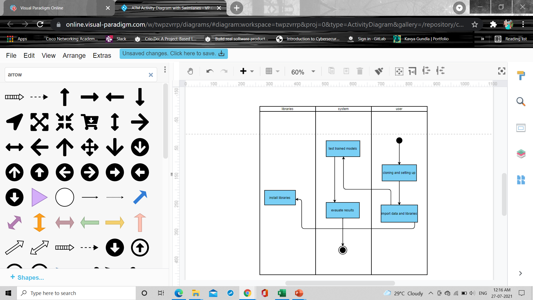

**4.System Implementation:**

The implementation stage of any project is a true display of the defining moments that make a project a success or a failure. The implementation stage is defined as the system or system modifications being installed and made operational in a production environment. The phase is initiated after the system has been tested and accepted by the user. This phase continues until the system is operating in production in accordance with the defined user requirements.

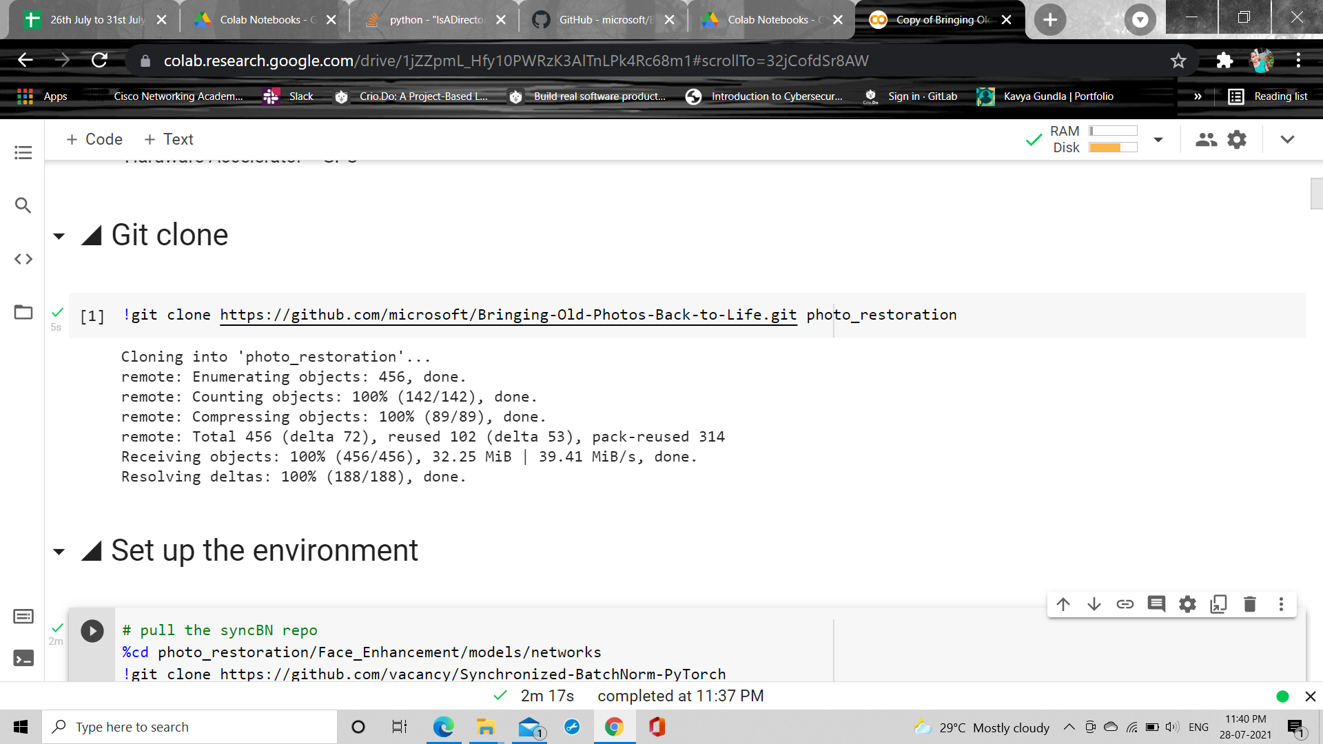

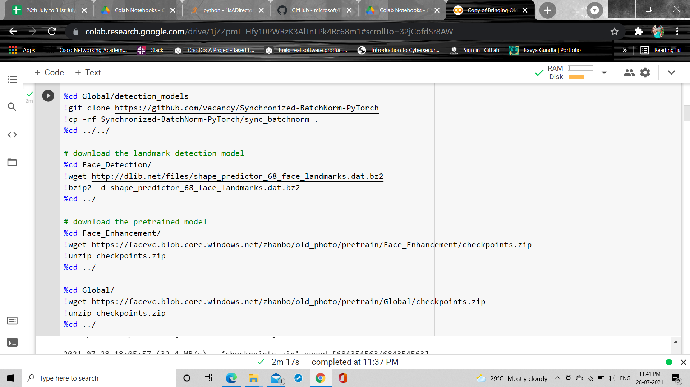

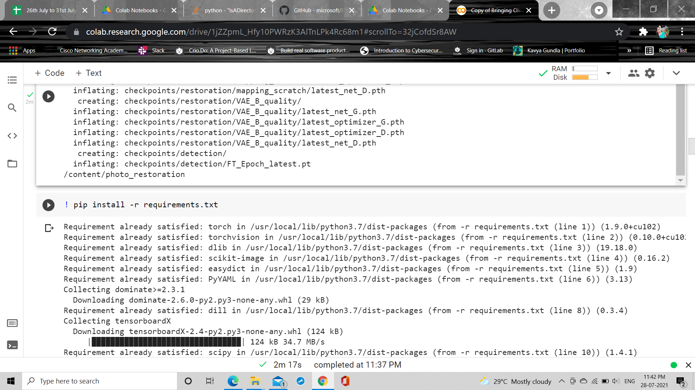

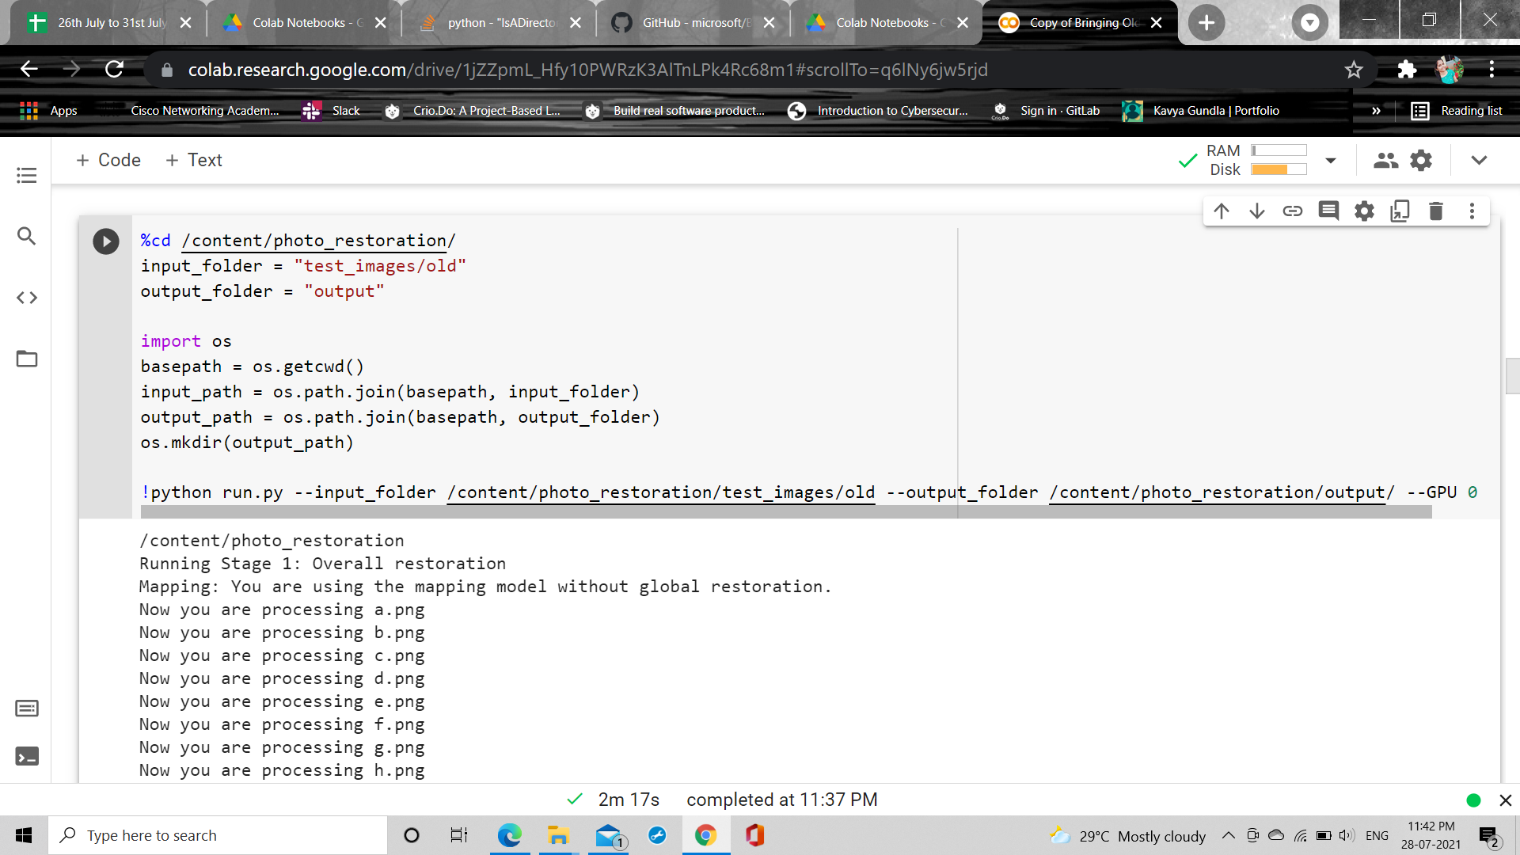

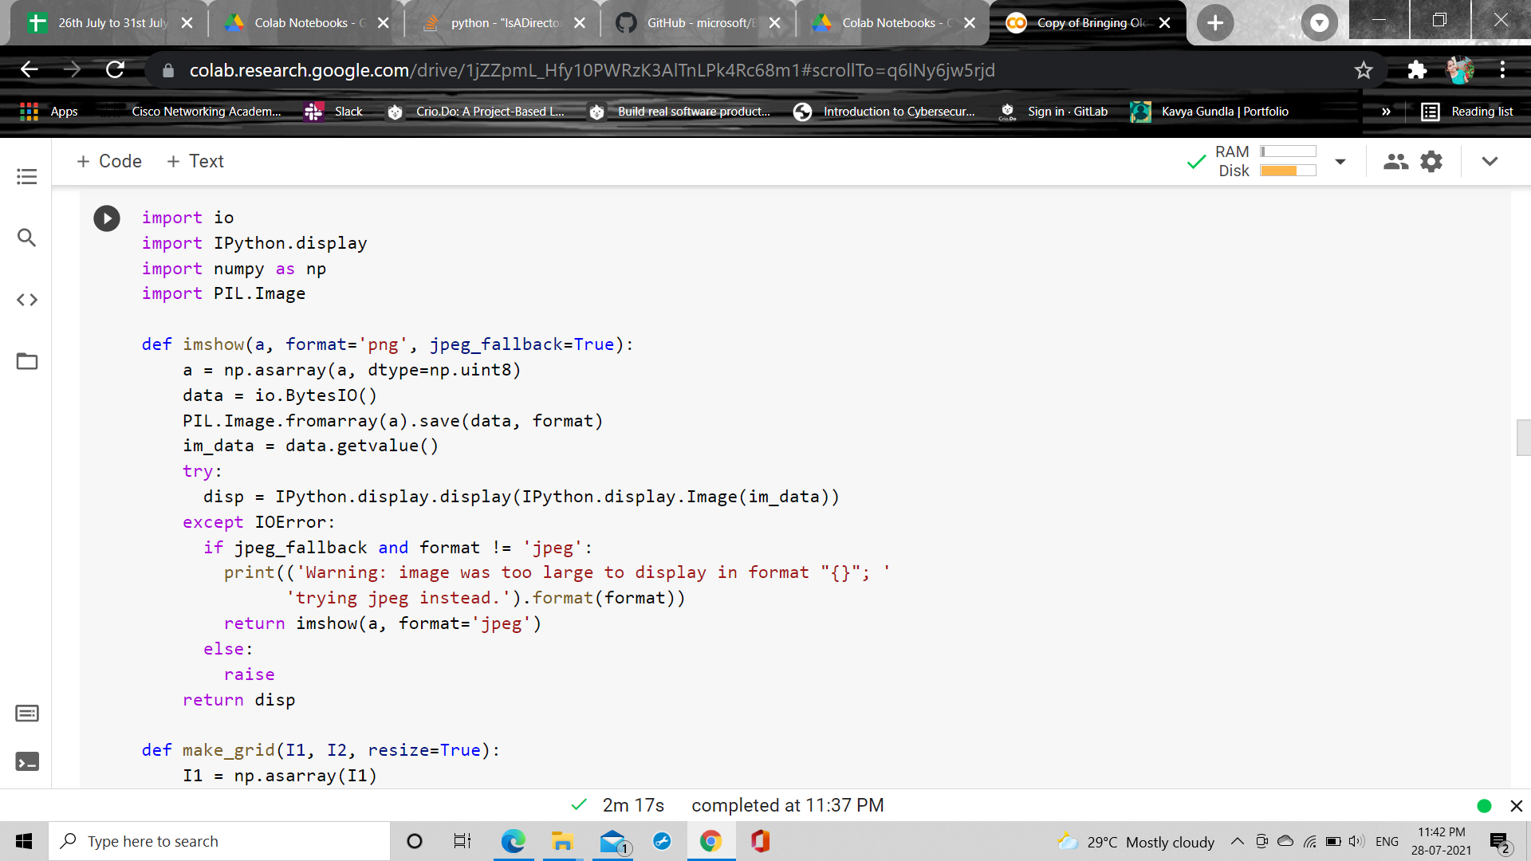

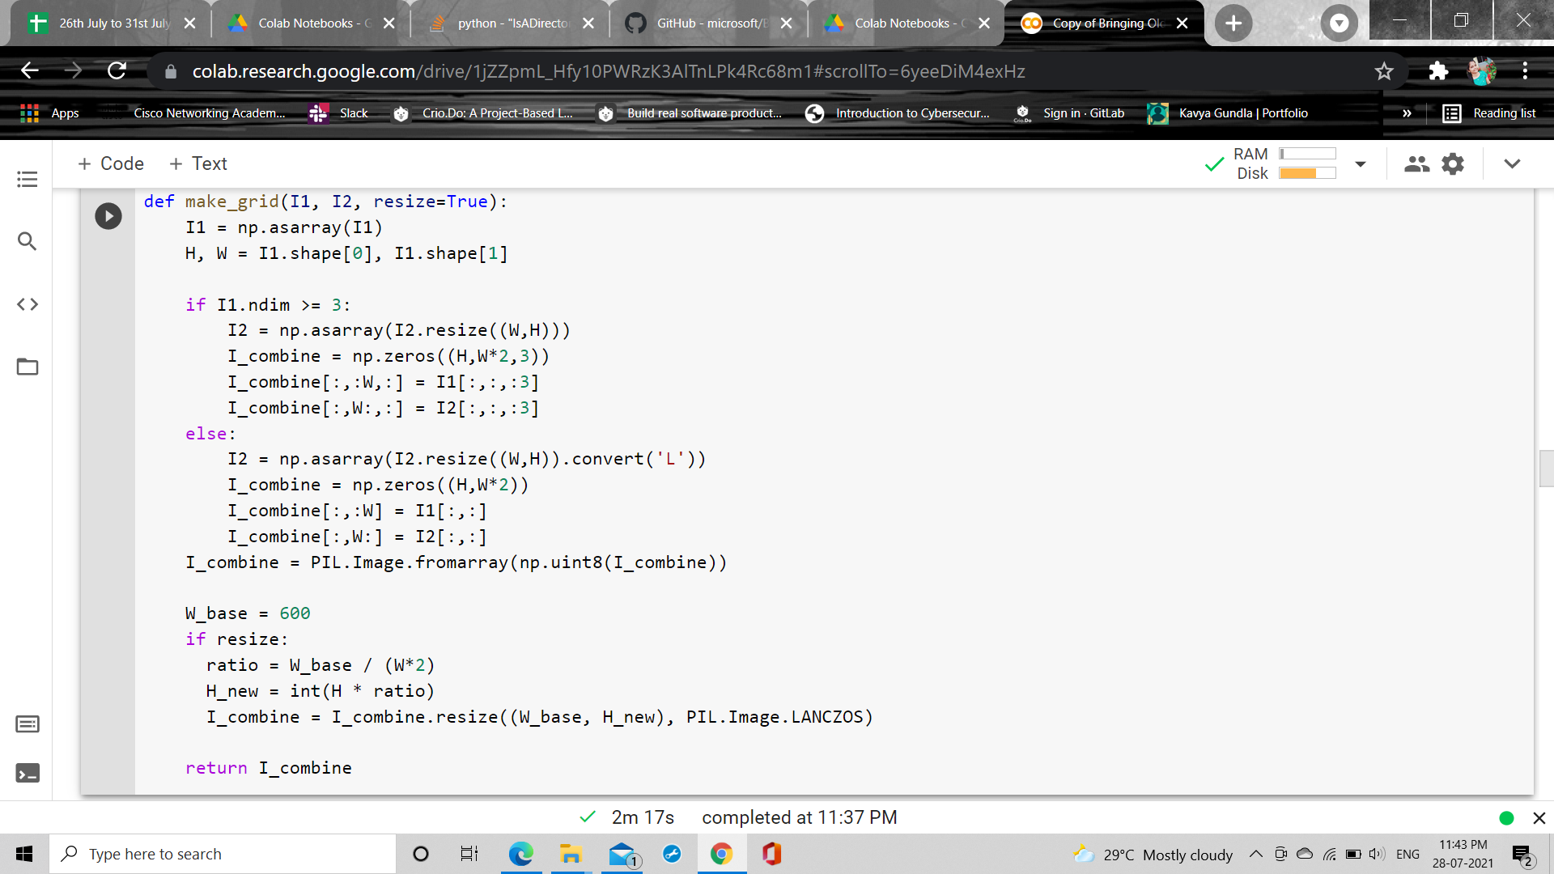

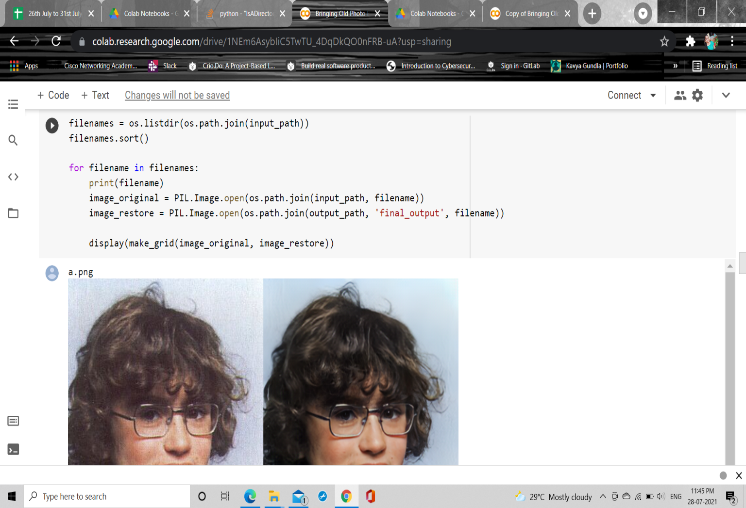

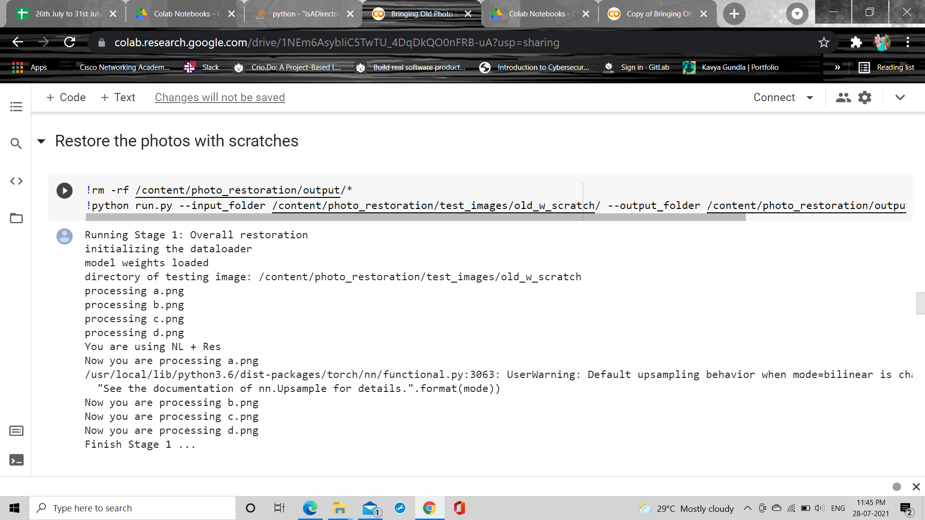

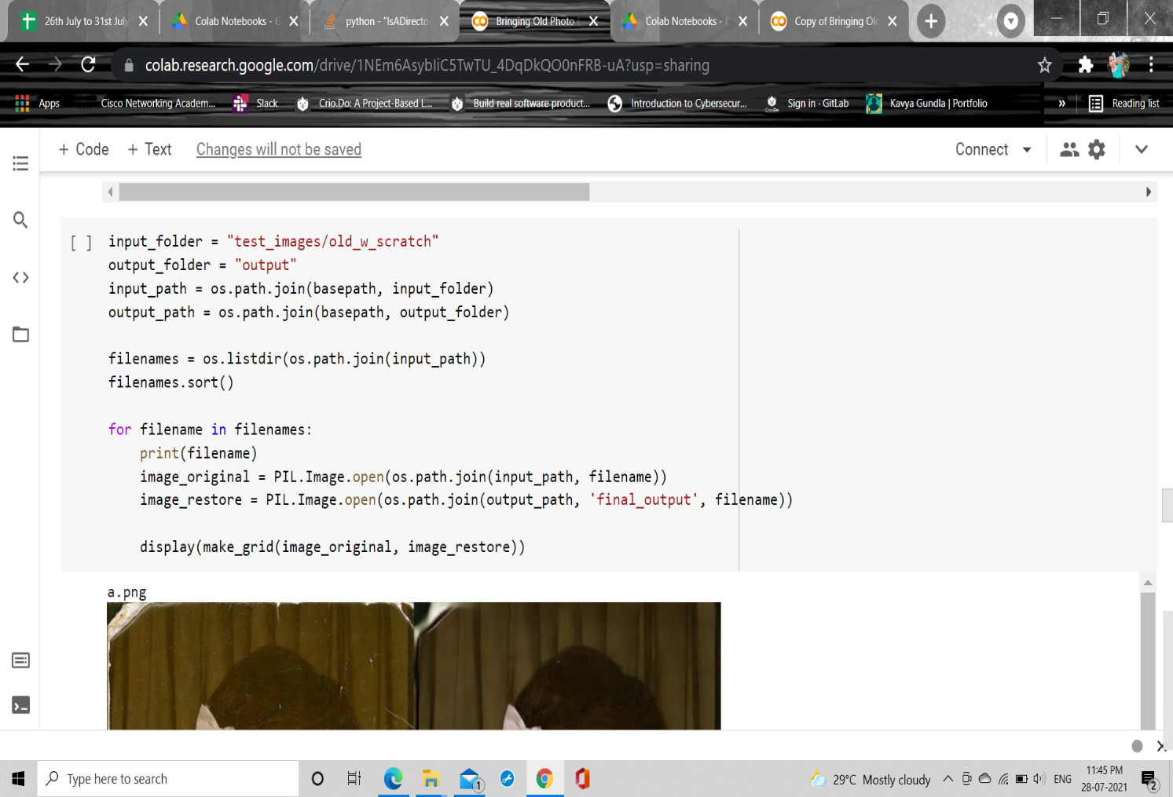

**5) OUTPUT IMAGES:**

Restored images without scratches:

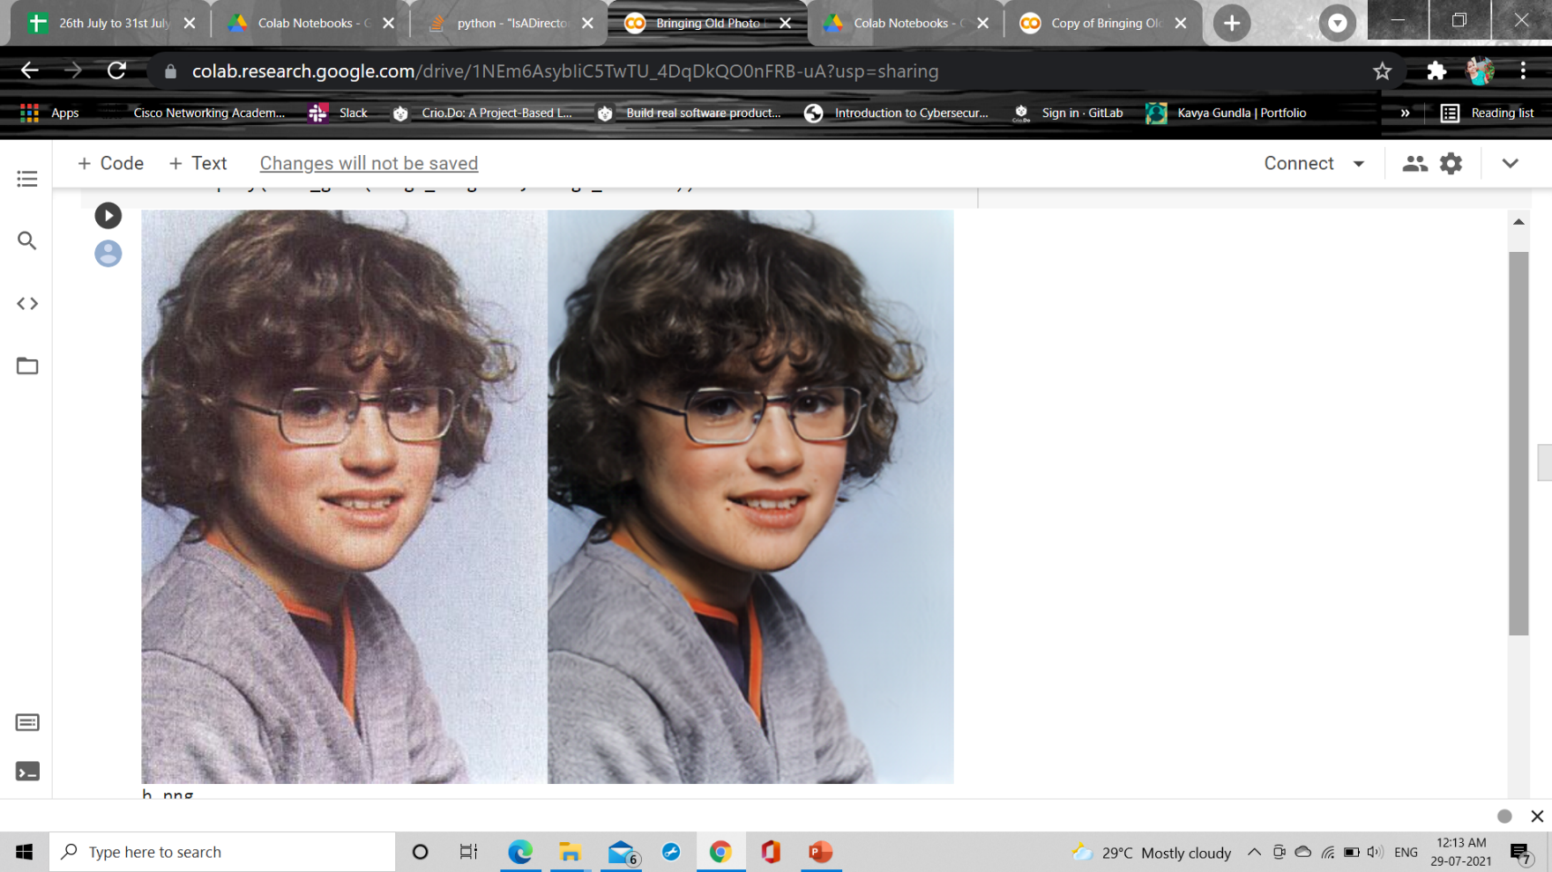

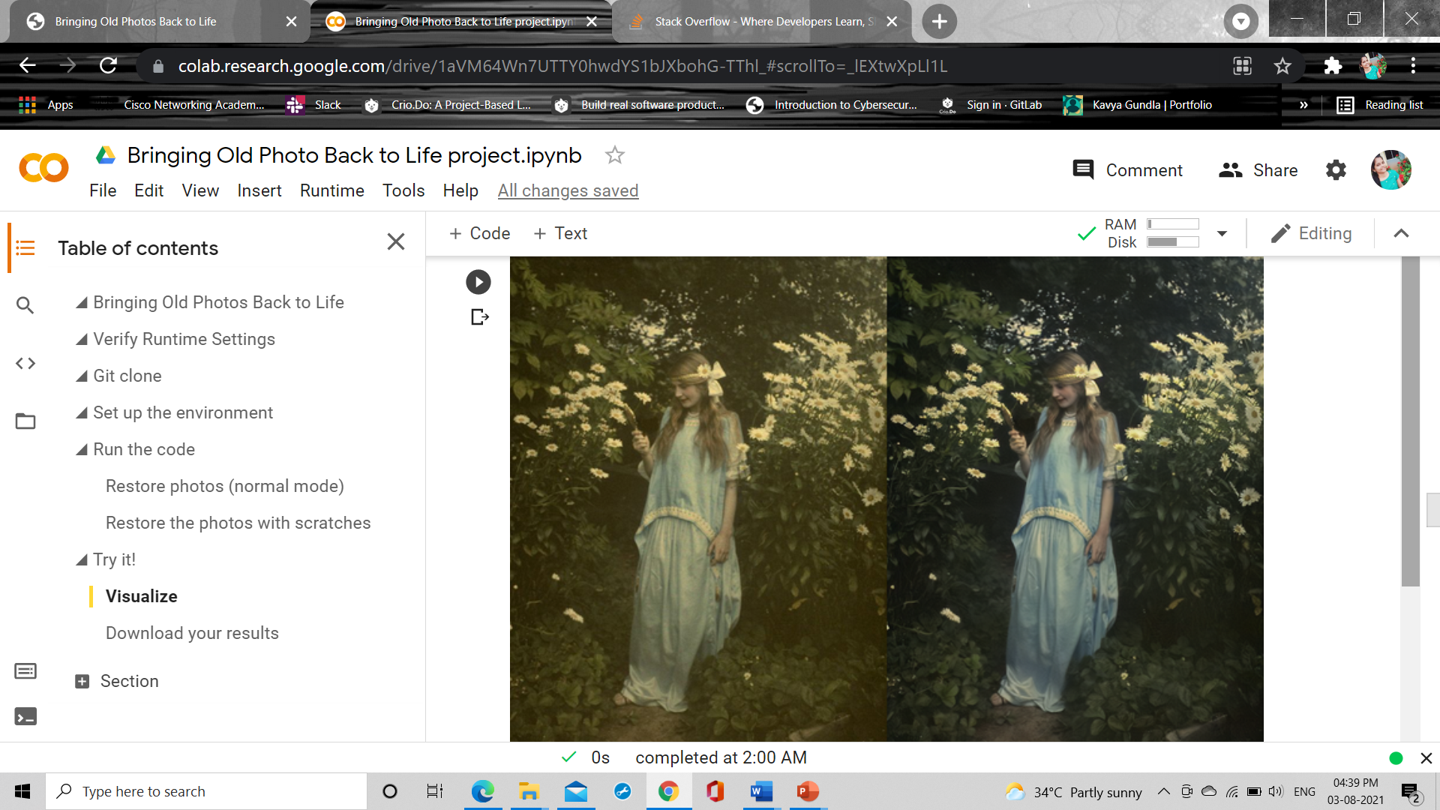

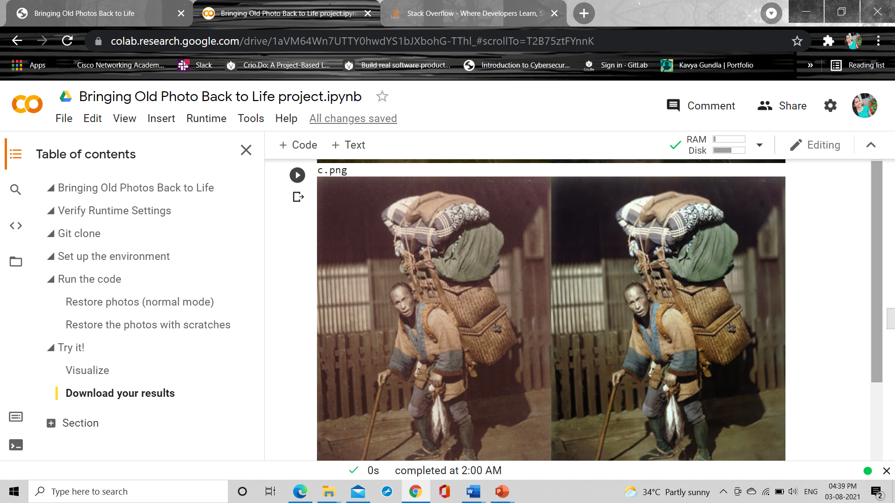

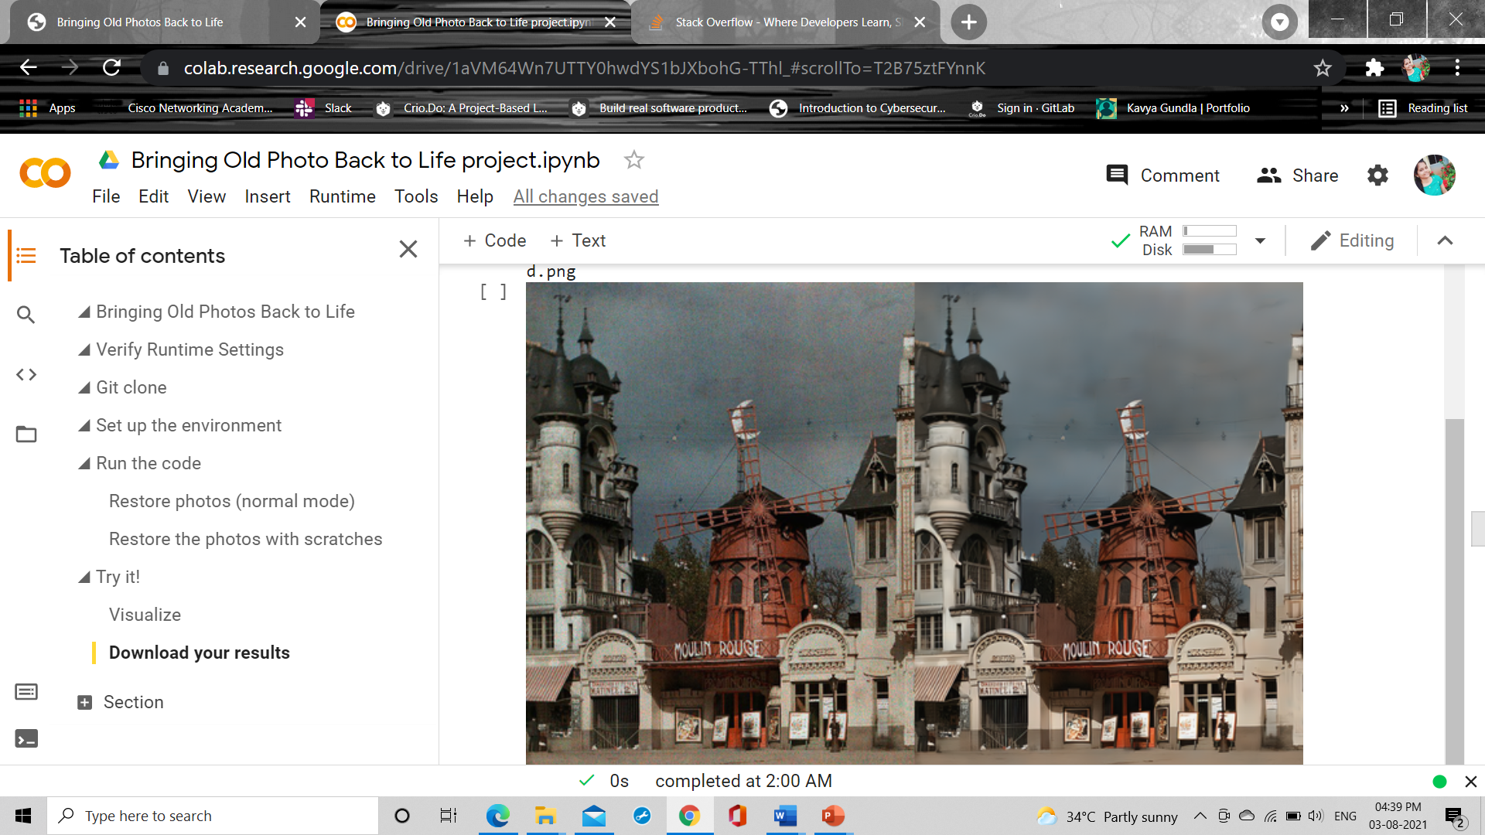

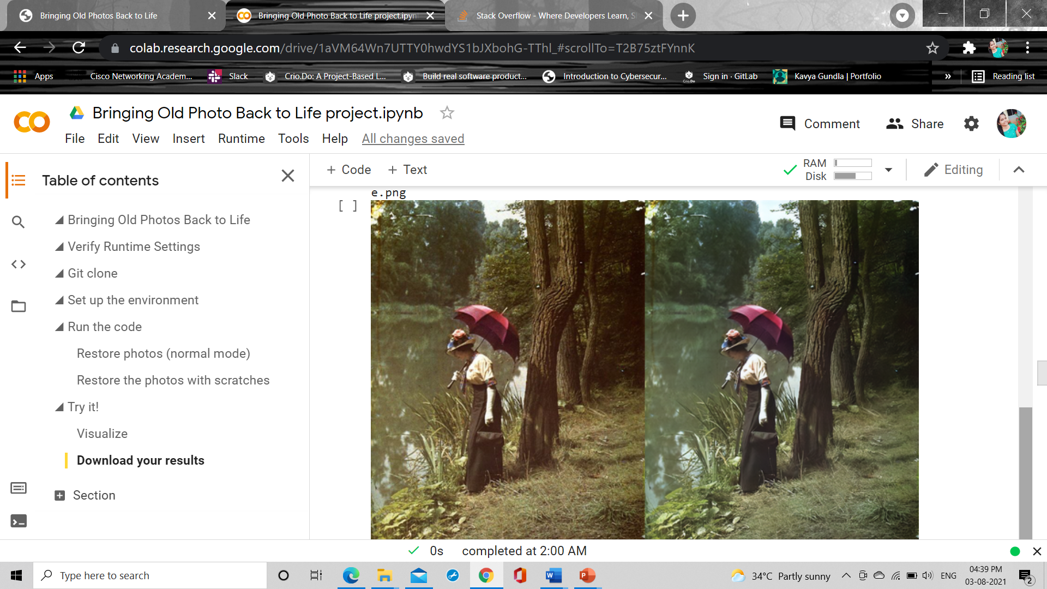

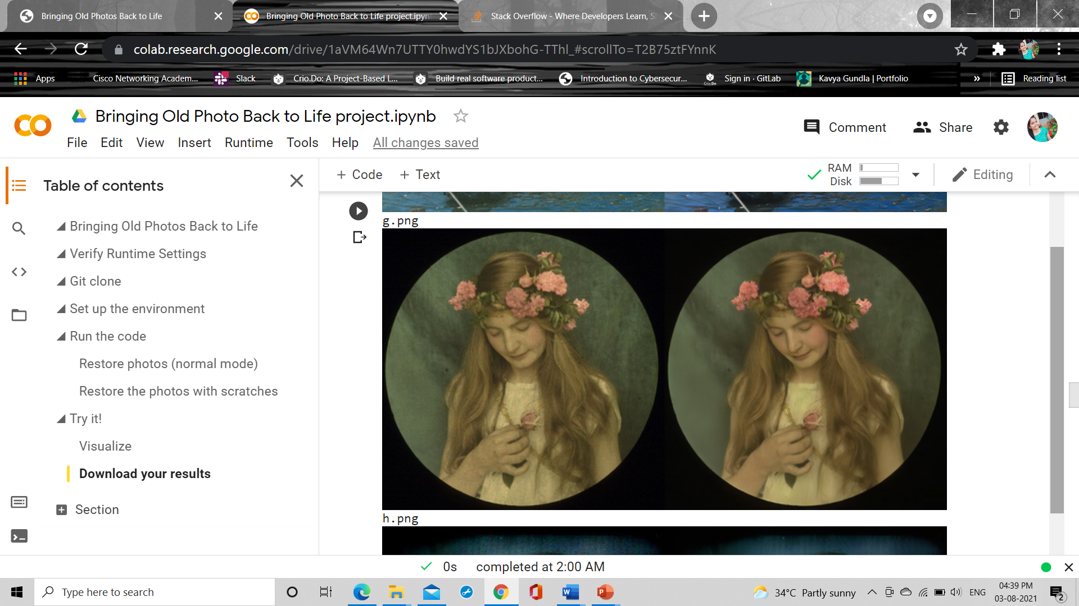

Restored images with scratches:

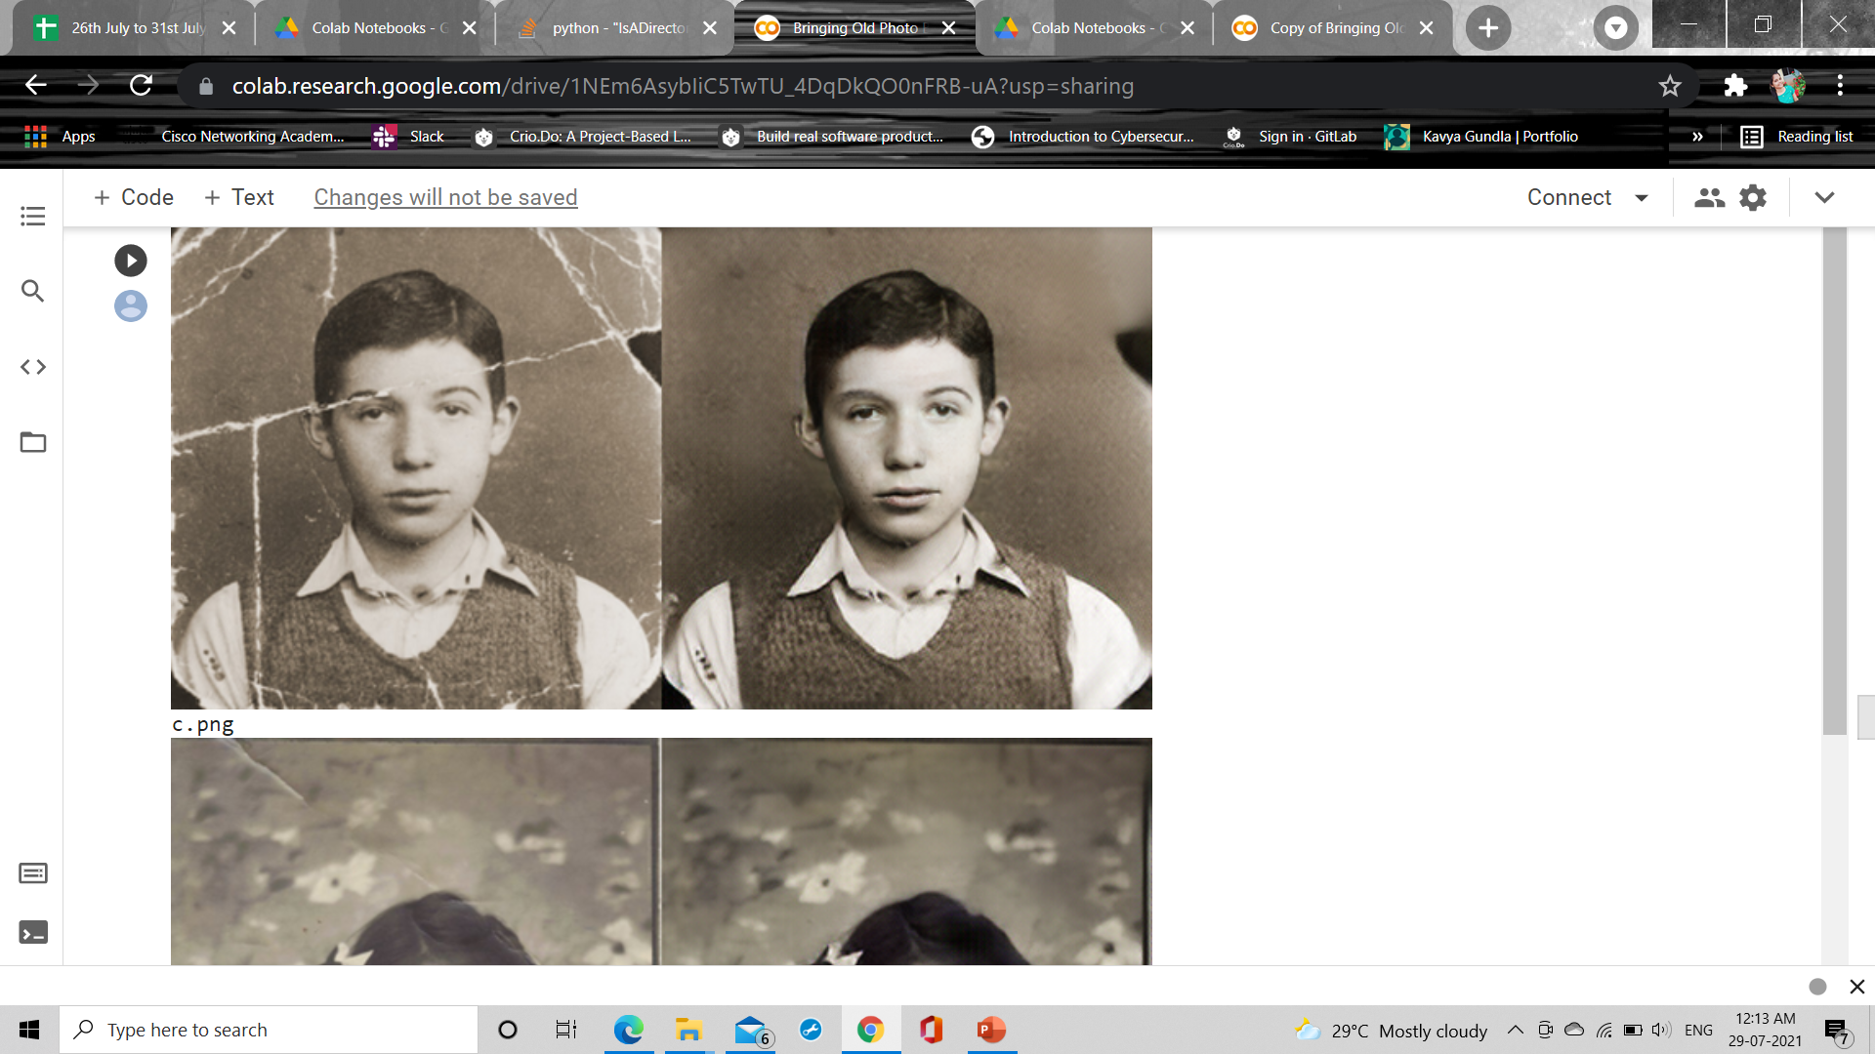

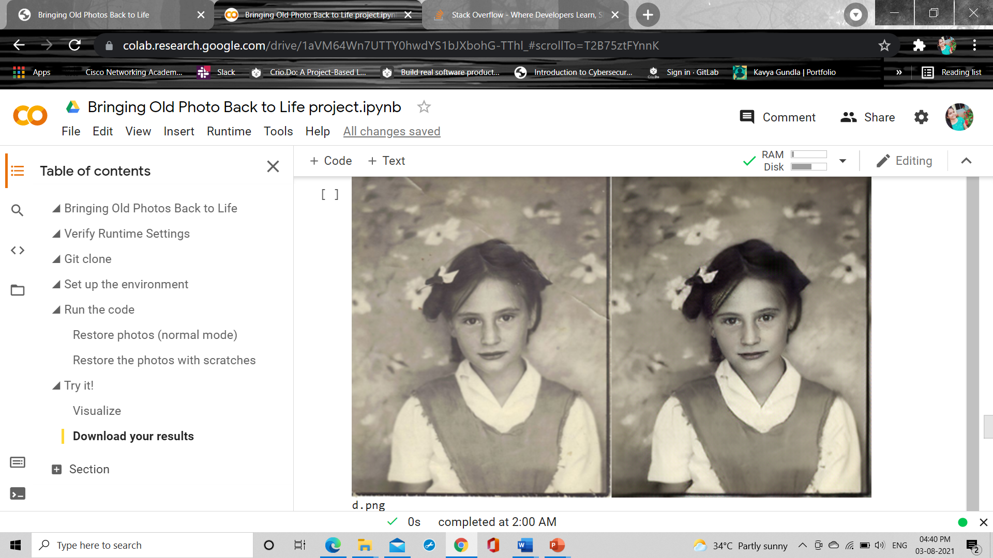

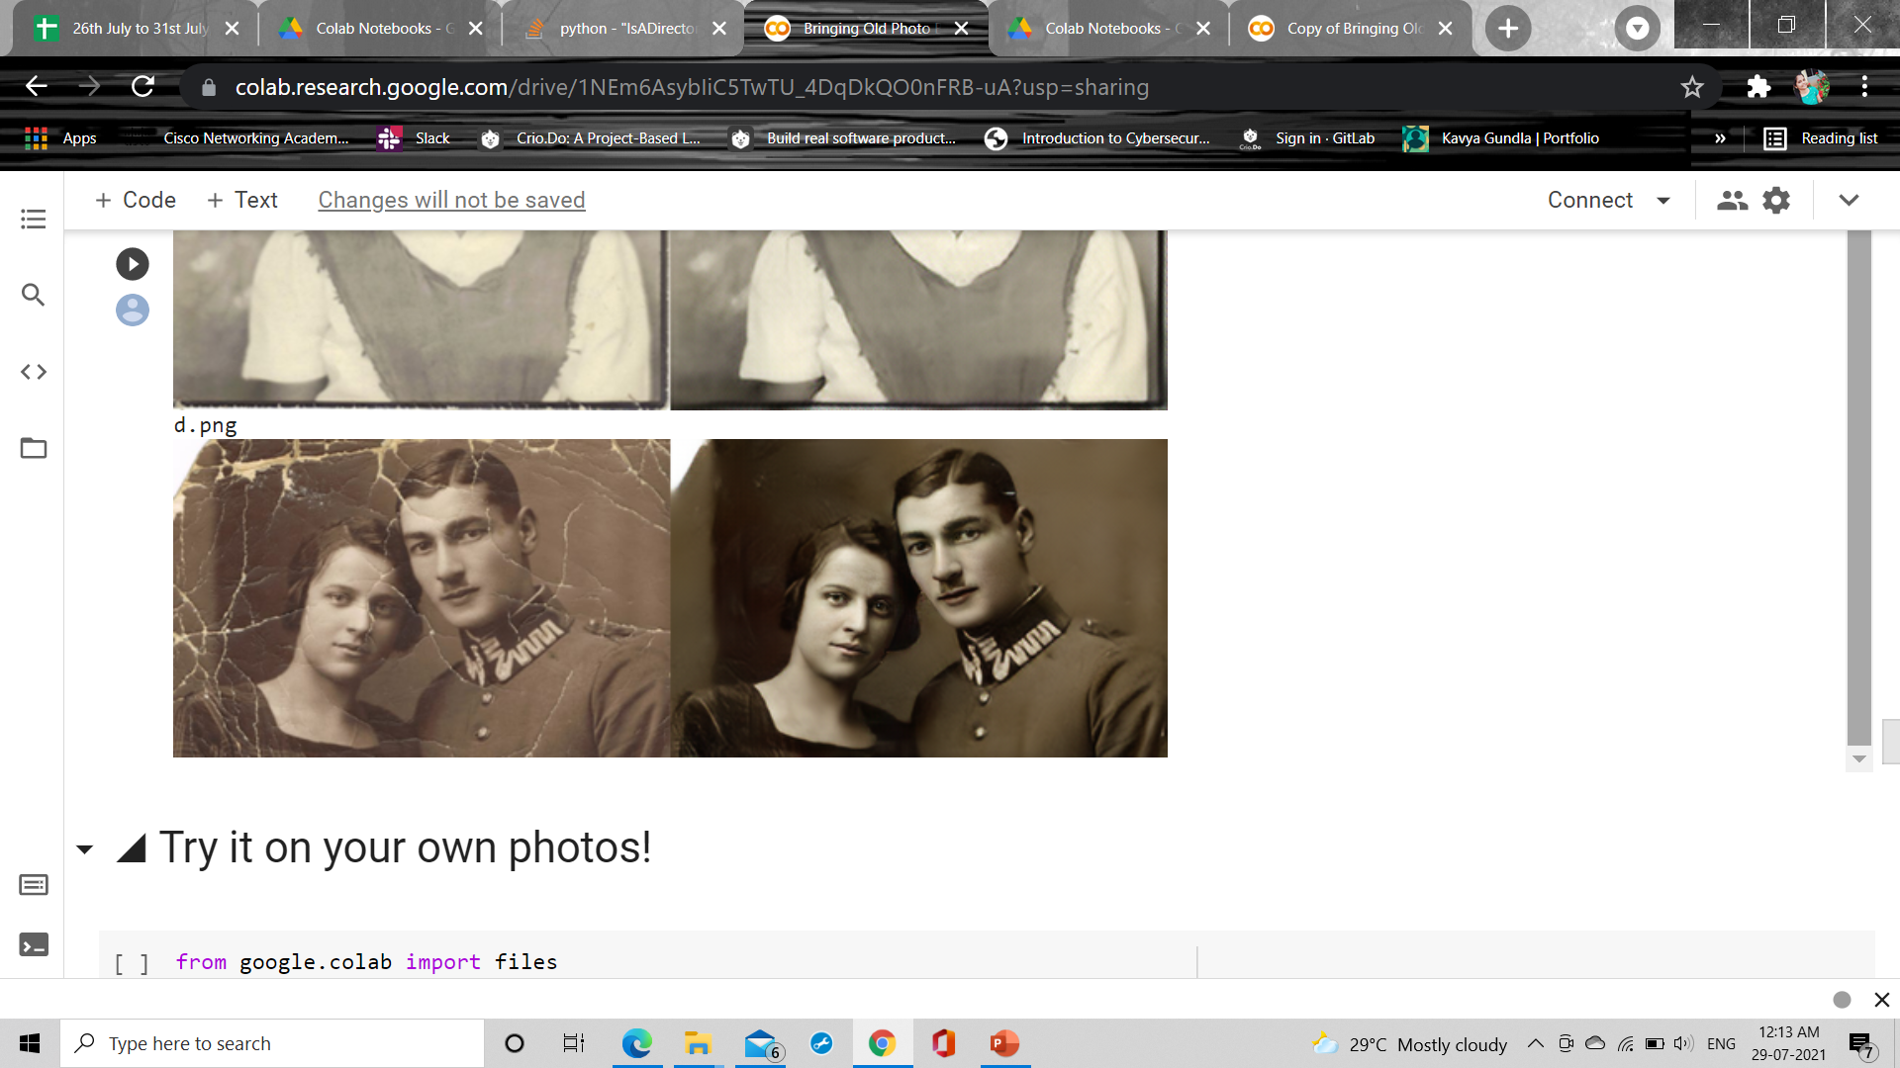

**6.Conclusion and Future Scope**:

We propose a novel triplet domain translation network that opens new avenue to restore the mixed degradation for inthe-wild old photos. The domain gap is reduced between old photos and synthetic images, and the translation to clean images is learned in latent space. Our method suffers less from generalization issue compared with prior methods. Besides, we propose a partial nonlocal block which restores the latent features by leveraging the global context, so the scratches can be inpainted with better structural consistency. Furthermore, we propose a coarse-to-fine generator with spatial adaptive condition to reconstruct the face regions of old photos.

Future Scope:

Our method demonstrates good performance in restoring severely degraded old photos. However, our method cannot handle complex shading . This is because our dataset contains few old photos with such defects. One could possibly address this limitation using our framework by explicitly considering the shading effects during synthesis or adding more such photos as training data.

**References:**

1) <https://stackoverflow.com/>

2) <https://www.geeksforgeeks.org/>

3)<https://www.w3schools.com/>

4) <http://raywzy.com/Old_Photo/>

**APPENDIX-A(PYTHON)**

**About Python**

**Python** is a programming language, which means it’a a language both people and computers can understand. Python was developed by a Dutch software engineer named Guido van Rossum, who created the language to solve some problems he saw in computer languages of the time.

**Python** is an interpreted high-level programming language for general-purpose programming. Created by Guido van Rossum and first released in 1991, Python has a design philosophy that emphasizes code readability, and a syntax that allows programmers to express concepts in fewer lines of code, notably using significant whitespace. It provides constructs that enable clear programming on both small and large scales.

Python features a dynamic type system and automatic memory management. It supports multiple programming paradigms, including object-oriented, imperative, functional and procedural, and has a large and comprehensive standard library.

Python interpreters are available for many operating systems. C Python, the reference implementation of Python, is open source software and has a community-based development model, as do nearly all of its variant implementations. C Python is managed by the non-profit

Python interpreters are available for many operating systems. C Python, the reference implementation of Python, is open source software and has a community-based development model, as do nearly all of its variant implementations. C Python is managed by the non-profit. C Python is managed by the non-profit Python Software Foundation.

**You Can Use Python for Pretty Much Anything**

One significant advantage of learning Python is that it’s a general-purpose language that can be applied in a large variety of projects. Below are just some of the most common fields where Python has found its use:

* Data science
* Scientific and mathematical computing
* Web development
* Computer graphics
* Basic game development
* Mapping and geography (GIS software)

**Python Is Widely Used in Data Science**

Python’s ecosystem is growing over the years and it’s more and more capable of the statistical analysis.

It’s the best compromise between scale and sophistication (in terms od data processing).

Python emphasizes productivity and readability.

Python is used by programmers that want to delve into data analysis or apply statistical techniques (and by devs that turn to data science)

There are plenty of Python scientific packages for data visualization, machine learning, natural language processing, complex data analysis and more. All of these factors make Python a great tool for scientific computing and a solid alternative for commercial packages such as MatLab. The most popular libraries and tools for data science are:

**Pandas**: a library for data manipulation and analysis. The library provides data structures and operations for manipulating numerical tables and time series.

**NumPy**: the fundamental package for scientific computing with Python, adding support for large, multi-dimensional arrays and matrices, along with a large library of high-level mathematical functions to operate on these arrays.

**SciPy**: a library used by scientists, analysts, and engineers doing scientific computing and technical computing.

Being a free, cross-platform, general-purpose and high-level programming language, Python has been widely adopted by the scientific community. Scientists value Python for its precise and efficient syntax, relatively flat learning curve and the fact that it integrates well with other languages (e.g. C/C++).

As a result of this popularity there are plenty of Python scientific packages for data visualization, machine learning, natural language processing, complex data analysis and more.

All of these factors make Python a great tool for scientific computing and a solid alternative for commercial packages such as Matlab.

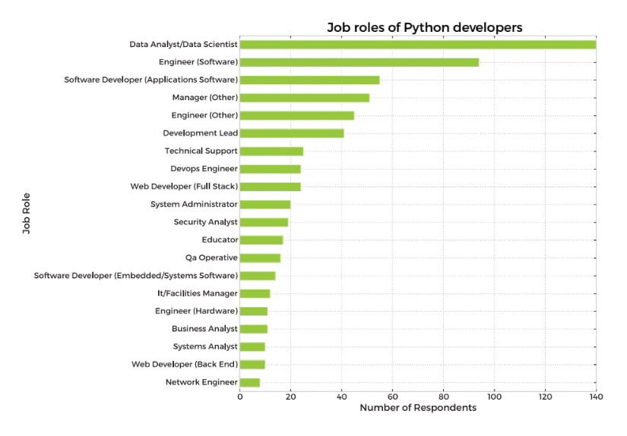

**Here’s our list of the most popular Python scientific libraries and tools**

**Astropy**

The Astropy Project is a collection of packages designed for use in astronomy. The core astropy package contains functionality aimed at professional astronomers and astrophysicists, but may be useful to anyone developing astronomy software.

**Biopython**

Biopython is a collection of non-commercial Python tools for computational biology and bioinformatics. It contains classes to represent biological sequences and sequence annotations, and it is able to read and write to a variety of file formats.

**Cubes**

Cubes is a light-weight Python framework and set of tools for the development of reporting and analytical applications, Online Analytical Processing (OLAP), multidimensional analysis and browsing of aggregated data.

**DEAP**

DEAP is an evolutionary computation framework for rapid prototyping and testing of ideas. It incorporates the data structures and tools required to implement most common evolutionary computation techniques such as genetic algorithm, genetic programming, evolution strategies, particle swarm optimization, differential evolution and estimation of distribution algorithm.

**SCOOP**

SCOOP is a Python module for distributing concurrent parallel tasks on various environments, from heterogeneous grids of workstations to supercomputers.

**PsychoPy**

PsychoPy is a package for the generation of experiments for neuroscience and experimental psychology. PsychoPy is designed to allow the presentation of stimuli and collection of data for a wide range of neuroscience, psychology and psychophysics experiments.

**Pandas**

Pandas is a library for data manipulation and analysis. The library provides data structures and operations for manipulating numerical tables and time series.

**Mlpy**

Mlpy is a machine learning library built on top of NumPy/SciPy, the GNU Scientific Libraries. Mlpy provides a wide range of machine learning methods for supervised and unsupervised problems and it is aimed at finding a reasonable compromise between modularity, maintainability, reproducibility, usability and efficiency.

**matplotlib**

Matplotlib is a python 2D plotting library which produces publication quality figures in a variety of hardcopy formats and interactive environments across platforms. Matplotlib allows you to generate plots, histograms, power spectra, bar charts, errorcharts, scatterplots, and more.

**NumPy**

NumPy is the fundamental package for scientific computing with Python, adding support for large, multi-dimensional arrays and matrices, along with a large library of high-level mathematical functions to operate on these arrays.

**NetworkX**

NetworkX is a library for studying graphs which helps you create, manipulate, and study the structure, dynamics, and functions of complex networks.

**TomoPy**

TomoPy is an open-sourced Python toolbox to perform tomographic data processing and image reconstruction tasks. TomoPy provides a collaborative framework for the analysis of synchrotron tomographic data with the goal to unify the effort of different facilities and beamlines performing similar tasks.

**Theano**

Theano is a numerical computation Python library. Theano allows you to define, optimize, and evaluate mathematical expressions involving multi-dimensional arrays efficiently.

**SymPy**

SymPy is a library for symbolic computation and includes features ranging from basic symbolic arithmetic to calculus, algebra, discrete mathematics and quantum physics. It provides computer algebra capabilities either as a standalone application, as a library to other applications, or live on the web.

**SciPy**

SciPy is a library used by scientists, analysts, and engineers doing scientific computing and technical computing. SciPy contains modules for optimization, linear algebra, integration, interpolation, special functions, FFT, signal and image processing, ODE solvers and other tasks common in science and engineering.

**Scikit-learn**

Scikit-learn is a machine learning library. It features various classification, regression and clustering algorithms including support vector machines, random forests, gradient boosting, k-means and DBSCAN, and is designed to interoperate with the Python numerical and scientific libraries NumPy and SciPy.

**Scikit-image**

Scikit-image is a image processing library. It includes algorithms for segmentation, geometric transformations, color space manipulation, analysis, filtering, morphology, feature detection, and more.

**ScientificPython**

ScientificPython is a collection of modules for scientific computing. It contains support for geometry, mathematical functions, statistics, physical units, IO, visualization, and parallelization.

**SageMath**

SageMath is mathematical software with features covering many aspects of mathematics, including algebra, combinatorics, numerical mathematics, number theory, and calculus. SageMath uses the Python, supporting procedural, functional and object-oriented constructs.

**Veusz**

Veusz is a scientific plotting and graphing package designed to produce publication-quality plots in popular vector formats, including PDF, PostScript and SVG.

**Graph-tool**

Graph-tool is a module for the manipulation and statistical analysis of graphs.

**SunPy**

SunPy is a data-analysis environment specializing in providing the software necessary to analyze solar and heliospheric data in Python.

**Bokeh**

Bokeh is a Python interactive visualization library that targets modern web browsers for presentation. Bokeh can help anyone who would like to quickly and easily create interactive plots, dashboards, and data applications. Its goal is to provide elegant, concise construction of novel graphics in the style of D3.js, but also deliver this capability with high-performance interactivity over very large or streaming datasets.

**TensorFlow**

TensorFlow is an open source software library for machine learning across a range of tasks, developed by Google to meet their needs for systems capable of building and training neural networks to detect and decipher patterns and correlations, analogous to the learning and reasoning which humans use. It is currently used for both research and production at Google products,‍ often replacing the role of its closed-source predecessor, DistBelief.

**Nilearn**

Nilearn is a Python module for fast and easy statistical learning on NeuroImaging data. Nilearn makes it easy to use many advanced machine learning, pattern recognition and multivariate statistical techniques on neuroimaging data for applications such as MVPA (Mutli-Voxel Pattern Analysis), decoding, predictive modelling, functional connectivity, brain parcellations, connectomes.

**Dmelt**

DataMelt, or DMelt, is a software for numeric computation, statistics, analysis of large data volumes ("big data") and scientific visualization. The program can be used in many areas, such as natural sciences, engineering, modeling and analysis of financial markets. DMelt can be used with several scripting languages including Python/Jython, BeanShell, Groovy, Ruby, as well as with Java.

**Python-weka-wrapper**

Weka is a suite of machine learning software written in Java, developed at the University of Waikato, New Zealand. It contains a collection of visualization tools and algorithms for data analysis and predictive modeling, together with graphical user interfaces for easy access to these functions. The python-weka-wrapper package makes it easy to run Weka algorithms and filters from within Python.

**Dask**

Dask is a flexible parallel computing library for analytic computing composed of two components: 1) dynamic task scheduling optimized for computation, optimized for interactive computational workloads, and 2) Big Data collections like parallel arrays, dataframes, and lists that extend common interfaces like NumPy, Pandas, or Python iterators to larger-than-memory or distributed environments.

**Python Saves Time**

Even the classic “Hello, world” program illustrates this point:

print("Hello, world")

For comparison, this is what the same program looks like in Java:

public class HelloWorld {

public static void main(String[] args) {

System.out.println("Hello, world");

}

}

**All the Big Names Use Python**

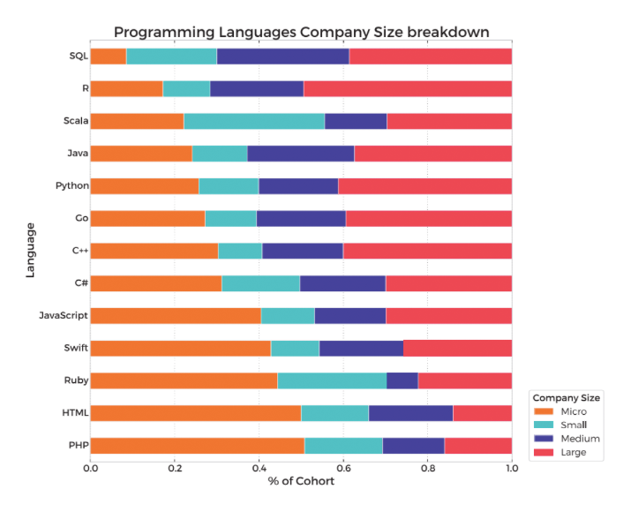

**Python Keywords and Identifier**

Keywords are the reserved words in Python.

We cannot use a keyword as variable name, function name or any other identifier. They are used to define the syntax and structure of the Python language.

In Python, keywords are case sensitive.

There are 33 keywords in Python 3.3. This number can vary slightly in course of time.

All the keywords except True, False and None are in lowercase and they must be written as it is. The list of all the keywords is given below.

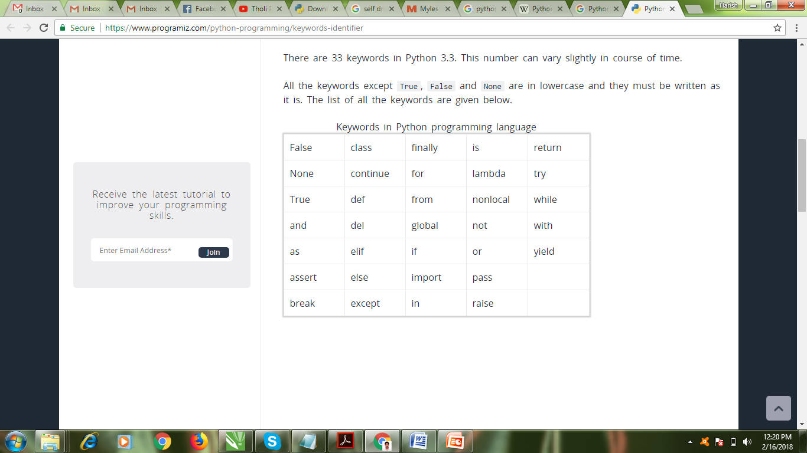

Identifier is the name given to entities like class, functions, variables etc. in Python. It helps differentiating one entity from another.

**Rules for writing identifiers**

Identifiers can be a combination of letters in lowercase (a to z) or uppercase (A to Z) or digits (0 to 9) or an underscore (_). Names like myClass, var_1 and print_this_to_screen, all are valid example.

An identifier cannot start with a digit. 1variable is invalid, but variable1 is perfectly fine.

Keywords cannot be used as identifiers.

>>>global = 1

File"<interactive input>", line 1

global = 1

^

SyntaxError: invalid syntax

We cannot use special symbols like !, @, #, $, % etc. in our identifier.

>>> a@ =0

File"<interactive input>", line 1

a@ =0

^

SyntaxError: invalid syntax

Identifier can be of any length.

**Python**

Python features a dynamic type system and automatic memory management. It supports multiple programming paradigms, including object-oriented, imperative, functional and procedural, and has a large and comprehensive standard library.

Python interpreters are available for many operating systems. C Python, the reference implementation of Python, is open source software and has a community-based development model, as do nearly all of its variant implementations. C Python is managed by the non-profit Python Software Foundation.



Python Logo

**Restoration via latent space translation**

In order to mitigate the domain gap, we formulate the old photo restoration as an image translation problem, where we treat clean images and old photos as images from distinct domains and we wish to learn the mapping in between.

However, as opposed to general image translation methods that bridge two different domains, we translate images across three domains: the real photo domain R, the synthetic domain X where images suffer from artificial degradation, and the corresponding ground truth domain Y that comprises images without degradation.

Such triplet domain translation is crucial in our task as it leverages the unlabeled real photos as well as a large amount of synthetic data associated with ground truth. We denote images from three domains respectively with r ∈ R, x ∈ X and y ∈ Y, where x and y are paired by data synthesis, i.e., x is degraded from y.

Directly learning the mapping from real photos {r} N i=1 to clean images {y} N i=1 is hard since they are not paired and thus unsuitable for supervised learning. We thereby propose to decompose the translation with two stages, which are illustrated in Figure 2. First, we propose to map R, X , Y to corresponding latent spaces via ER : R 7→ ZR, EX : X 7→ ZX , and EY : Y 7→ ZY , respectively. In particular, because synthetic images and real old photos are both corrupted, sharing similar appearances, we align their latent space into the shared domain by enforcing some constraints. Therefore we have ZR ≈ ZX . This aligned latent space encodes features for all the corrupted images, either synthetic or real ones. Then we propose to learn the image restoration in the latent space. Specifically, by utilizing the synthetic data pairs {x, y} N i=1, we learn the translation from the latent space of corrupted images, ZX , to the latent space of ground truth, ZY , through the mapping TZ : ZX 7→ ZY , where ZY can be further reversed to Y through generator GY : ZY 7→ Y. By learning.

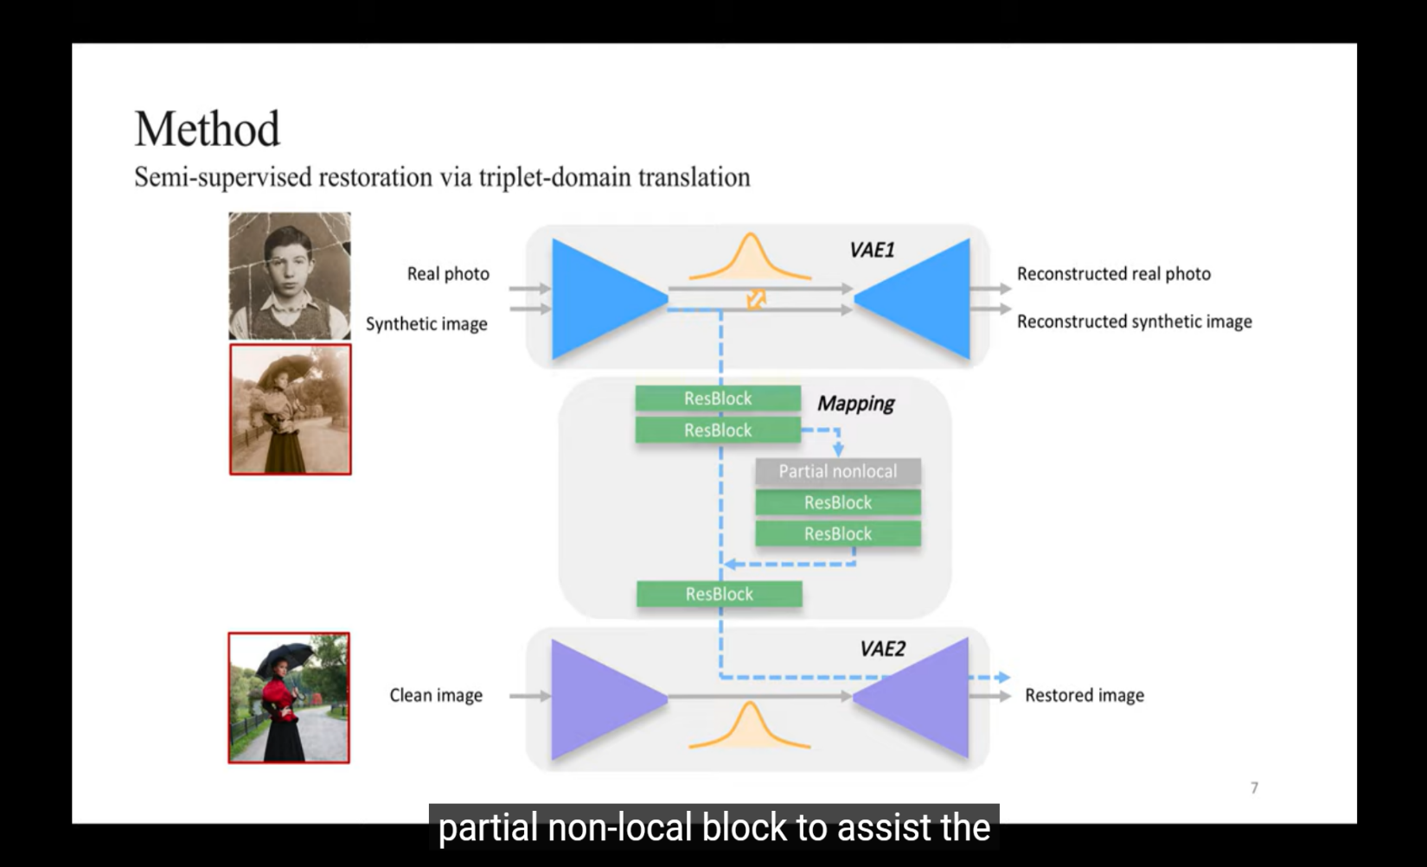

the latent space translation, real old photos r can be restored by sequentially performing the mappings, rR→Y = GY ◦ TZ ◦ ER(r). (1) Domain alignment in the VAE latent space One key of our method is to meet the assumption that R and X are encoded into the same latent space. To this end, we propose to utilize variational autoencoder (VAE) to encode images with compact representation, whose domain gap is further examined by an adversarial discriminator . We use the network architecture to realize this concept.

In the first stage, two VAEs are learned for the latent representation. Old photos {r} and synthetic images {x} share the first one termed VAE1, with the encoder ER,X and generator GR,X , while the ground true images {y} are fed into the second one, VAE2 with the encoder-generator pair {EY , GY }. VAE1 is shared for both r and x in the aim that images from both corrupted domains can be mapped to a shared latent space.

The VAEs assumes Gaussian prior for the distribution of latent codes, so that images can be reconstructed by sampling from the latent space. We use the re-parameterization trick to enable differentiable stochastic sampling and optimize VAE1 with data {r} and {x} respectively. The objective with {r} is defined as: LVAE1 (r) = KL(ER,X (zr|r)||N (0, I)) + αEzr∼ER,X (zr|r) kGR,X (rR→R|zr) − rk1 + LVAE1,GAN(r)

where, zr ∈ ZR is the latent codes for r, and rR→R is the generation outputs. The first term in equations is the KL-divergence that penalizes deviation of the latent distribution from the Gaussian prior. The second `1 term lets the VAE reconstruct the inputs, implicitly enforcing latent codes to capture the major information of images. Besides, we introduce the least-square loss (LSGAN) [54], denoted as LVAE1,GAN in the formula, to address the well-known over-smooth issue in VAEs, further encouraging VAE to reconstruct images with high realism.

The objective with {x}, denoted as LVAE1 (x), is defined similarly. And VAE2 for domain Y is trained with a similar loss so that the corresponding latent representation zy ∈ Y can be derived. We use VAE rather than vanilla autoencoder because VAE features denser latent representation due to the KL regularization (which will be proved in ablation study), and this helps produce closer latent space for {r} and {x} with VAE1 thus leading to smaller domain gap. To further narrow the domain gap in this reduced space, we propose to use an adversarial network to examine the residual latent gap.

Concretely, we train another discriminator DR,X that differentiates ZR and ZX , whose loss is defined as, L latent VAE1,GAN(r, x) = Ex∼X [DR,X (ER,X (x))2 ] + Er∼R[(1 − DR,X (ER,X (r)))2 ]. Meanwhile, the encoder ER,X of VAE1 tries to fool the discriminator with a contradictory loss to ensure that R and X are mapped to the same space. Combined with the latent adversarial loss, the total objective function for VAE1 becomes, min ER,X ,GR,X max DR,X LVAE1 (r)+LVAE1 (x)+L latent VAE1,GAN(r, x).

Restoration through latent mapping With the latent code captured by VAEs, in the second stage, we leverage the synthetic image pairs {x, y} and propose to learn the image restoration by mapping their latent space (the mapping network M in Figure 3). The benefit of latent restoration is threefold. First, as R and X are aligned into the same latent space, the mapping from ZX to ZY will also generalize well to restoring the images in R. Second, the mapping in a compact low-dimensional latent space is in principle much easier to learn than in the high-dimensional image space.

In addition, since the two VAEs are trained independently and the reconstruction of the two streams would not be interfered with each other. The generator GY can always get an absolutely clean image without degradation given the latent code zY mapped from ZX , whereas degradations will likely remain if we learn the translation in pixel level. Let rR→Y , xX→Y and yY→Y be the final translation outputs for r, x and y, respectively.

At this stage, we solely train the parameters of the latent mapping network T and fix the two VAEs. The loss function LT , which is imposed at both the latent space and the end of generator GY , consists of three terms, LT (x, y) = λ1LT ,`1 + LT ,GAN + λ2LFM where the latent space loss, LT ,`1 = E kT (zx) − zy)k1 , penalizes the `1 distance of the corresponding latent codes.

We introduce the adversarial loss LT ,GAN, still in the form of LSGAN , to encourage the ultimate translated synthetic image xX→Y to look real. Besides, we introduce feature matching loss LFM to stabilize the GAN training.

Specifically, LFM matches the multi-level activations of the adversarial network DM, and that of the pretrained VGG network (also known as perceptual loss in ), i.e., LFM = E hX i 1 n i DT kφ i DT (xX→Y ) − φ i DT (yY→Y )k1 + X i 1 n i VGG kφ i VGG(xX→Y ) − φ i VGG(yY→Y )k1 i , where φ i DT (φ i VGG) denotes the i th layer feature map of the discriminator (VGG network), and n i DT (n i VGG) indicates the number of activations in that layer.

**Multiple degradation restoration**

The latent restoration using the residual blocks, as described earlier, only concentrates on local features due to the limited receptive field of each layer. Nonetheless, the restoration of structured defects requires plausible inpainting, which has to consider long-range dependencies so as to ensure global structural consistency. Since legacy photos often contain mixed degradations, we have to design a restoration network that simultaneously supports the two mechanisms.

Towards this goal, we propose to enhance the latent restoration network by incorporating a global branch as shown which composes of a nonlocal block that considers global context and several residual blocks in the following. While the original block proposed in is unaware of the corruption area, our nonlocal block explicitly utilizes the mask input so that the pixels in the corrupted region will not be adopted for completing those area. Since the context considered is a part of the feature map, we refer to the module specifically designed for the latent inpainting as a partial nonlocal block.

Formally, let F ∈ R C×HW be the intermediate feature map in M (C, H and W are number of channels, height and width respectively), and m ∈ {0, 1} HW represents the binary mask downscaled to the same size, where 1 represents the defect regions to be inpainted and 0 represents the intact regions. The affinity between i th location and j th location in F, denoted by si,j ∈ R HW×HW , is calculated by the correlation of Fi and Fj modulated by the mask (1−mj ), i.e., si,j = (1 − mj )fi,j/ X ∀k (1 − mk)fi,k, (7) where, fi,j = exp(θ(Fi) T · φ(Fj )) gives the pairwise affinity with embedded Gaussian. Here, θ and φ project F to Gaussian space for affinity calculation.

According to the affinity si,j that considers the holes in the mask, the partial nonlocal finally outputs Oi = ν X ∀j si,jµ(Fj ) , (which is a weighted average of correlated features for each position. We implement the embedding functions θ, φ, µ and ν with 1×1 convolutions.

We design the global branch specifically for inpainting and hope the non-hole regions are left untouched, so we fuse the global branch with the local branch under the guidance of the mask, i.e., Ffuse = (1 − m) ρlocal(F) + m ρglobal(O), where operator denotes Hadamard product, and ρlocal and ρglobal denote the nonlinear transformation of residual blocks in two branches. In this way, the two branches constitute the latent restoration network, which is capable to deal with multiple degradation in old photos.

**Defect Region Detection**

Since the global branch of our restoration network requires a mask m as the guidance, in order to get the mask automatically, we train a scratch detection network in a supervised way by using a mixture of real scratched dataset and synthetic dataset. Specifically, let {si , yi |si ∈ S, yi ∈ Y} denote the whole training pairs, where si and yi are the scratched image and the corresponding binary scratch mask respectively, we use the cross-entropy loss to minimize the difference between the predicted mask yˆi and yi , LCE =E(si,yi)∼(S,Y) ( α X H h=1 X W w=1 −y (h,w) i log ˆyi (h,w) − (1 − α) X H h=1 X W w=1 (1 − y (h,w) i ) log(1 − yˆi (h,w) ) ) . Since the scratch regions are often a small portion of the whole image, here we use a weight αi to remedy the imbalance of positive and negative pixel samples. To determine the detailed value of αi , we compute the positive/negative proportion of yi on the fly, αi = [yi = 1] [yi = 1] + [yi = 0]].

**Face Enhancement**

The restoration network proposed above is general to all kinds of old photos. However, considering restoration quality on faces is most sensitive to human perception, we further propose a network for face enhancement. Given one real degraded photo r, we hope to reconstruct degraded faces rf in r into a much detailed and clean version with proposed face enhancement network Gf . The classical pixel-wise translation method could not solve such a blind restoration problem well because the degradation prior is totally unknown. Here, we solve this problem from the perspective of generative models.

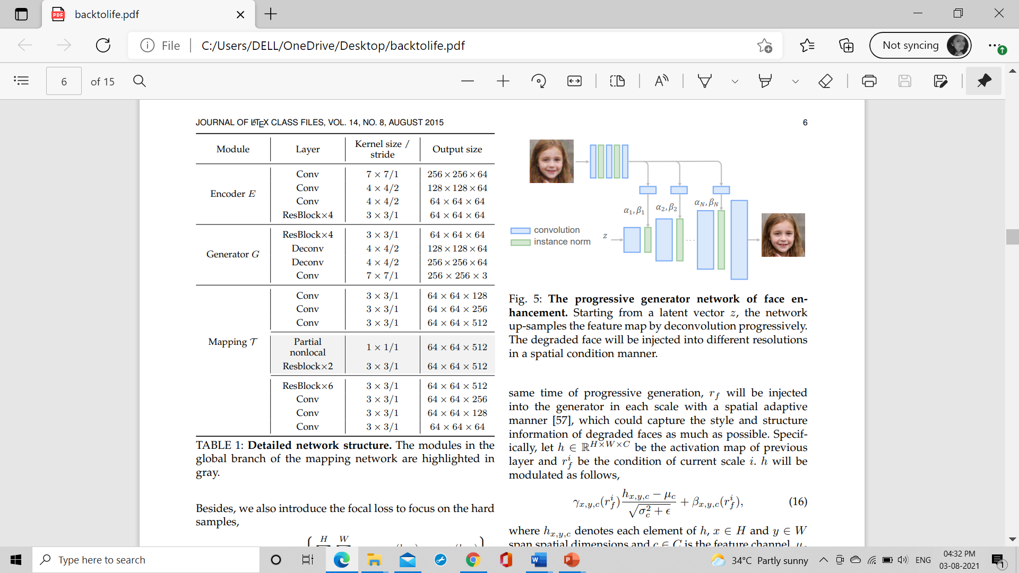

We employ a coarse-to-fine generator to translate a low-dimensional code z into corresponding high-resolution and clean faces, where z is a downsampled patch of rf (8 × 8 in our implementation). At the same time of progressive generation, rf will be injected into the generator in each scale with a spatial adaptive manner , which could capture the style and structure information of degraded faces as much as possible. Specifically, let h ∈ R H×W×C be the activation map of previous layer and r i f be the condition of current scale i. h will be modulated as follows, γx,y,c(r i f ) hx,y,c − µc p σ 2 c + + βx,y,c(r i f ), where hx,y,c denotes each element of h, x ∈ H and y ∈ W span spatial dimensions and c ∈ C is the feature channel. µc and σc are the mean and standard deviation of the activation h in channel c. is a constant factor to avoid outlier values, γx,y,c(r i f ) and βx,y,c(r i f ) are two learnable scalars locally controlling the influence from r i f . In practice, we use two convolutional layers to generate these two coefficients at each element location.

To train the proposed face enhancement network, we penalize the perceptual distance between the generated face Gf (z, rf ) and high-resolution rc as follows, L face perc = E hX i 1 n i VGG kφ i VGG(Gf (z, rf ))−φ i VGG(rc)k1 i , where rf is the degraded face of rc and z is the latent code of rf . Besides, another adversarial loss is involved in the training procedure to ensure the synthesis of high-frequency details, L face GAN(z, rf , rc) = Ez∼Z,rf ∼Rf [Df (Gf (z, rf ))2 ] + Erc∼Rc [(1 − Df (rc))2 ]. The face enhance network is jointly trained with previous restoration network to ensure better generalization ability, i.e., rf is the output of triplet domain translation network. We found such training scheme could effectively suppress the generated artifacts. More detailed analysis about joint training could be found . During inference, we firstly search the face parts of arbitrary photos, and then refine this region with proposed enhancement network.

As a result of generative model, there sometimes exists color shifting between reconstructed faces and input degraded faces. We solve this issue by histogram matching. Finally the reconstructed face will be combined with original input photo using linear blending to produce the final results.

**Data Generation**

Next, we brief the old photo synthesis procedure. Though we cannot fully emulate the old photo style, a careful synthesis is vital to high-quality restoration as support overlap between two domain distributions eases domain adaptation .

**Unstructured Degradation**

We use the following operations to simulate the unstructured degradation. Specifically,

1. Gaussian white noise with σ ∈ (5, 50).

2) Gaussian blur with kernel size k ⊂ {3, 5, 7} and standard deviation σ ∈ (1.0, 5.0); 3) 3)JPEG compression whose quality level in the range of (40, 100);

4) Color jitter which randomly shifts the RGB color channels by (−20, 20);

5) Box blur to mimic the lens defocus.

We apply above types of augmentations with varying parameters in random order. To achieve more variations, we stochastically drop out each type of operation with 30% probability. Still, the synthesis cannot exactly match the appearance of real photo defects, thus requiring the proposed network to further reduce the domain gap.

**Structured Degradation**

.As described, to train the defect region detection network, a mixture of synthetic and real scratch datasets are used (pretrain on synthetic and finetune on real). For the synthetic part, we collect 62 scratch texture images and 55 paper texture images, which are further augmented with elastic distortions. Then we use layer addition, lighten-only and screen modes with random level of opacity to blend the scratch textures over the natural images from the Pascal VOC dataset . Besides, in order to simulate large-area photo damage, we generate holes with feathering and random shape where the underneath paper texture is unveiled.

Note that we also introduce film grain noise and blur with random kernel to simulate the global defects at this stage so that the synthetic data has a similar global style as the real old photos. These injected noises are beneficial in that they make the distribution of synthetic and real data become more overlapped. Examples of synthesized scratched old photos are shown .

To improve the detection performance on real old photos, we collect 783 real old photos and manually annotate the local defects, among which 400 images are used for training and remaining for testing.As shown in Figure 6, adding the real data into training can significantly boost the scratch detection performance on real old photos and achieve AUC as 0.912. Some sampled scratch detection masks and restoration results of test dataset.

**Latent translation with VAEs**

Let us consider the following variants, with proposed components added one-by-one:

• Pix2Pix which learns the translation in image-level. The model is trained using only synthetic pairs. • Two VAEs with an additional KL loss to penalize the latent space. The VAEs and latent mapping are all trained simultaneously.

• VAEs with two-stage training (VAEs-TS): the two VAEs are first trained separately and the latent mapping is learned thereafter with the two fixed VAEs, which ensure the translation is performed in two fix domains.

• Full model, which also adopts latent adversarial loss.

Effectiveness of Joint Training The face enhancement network is jointly trained with the triplet domain translation network, i.e., input corrupted faces will first pass through this translation network, and then be reconstructed into a high-resolution version with the proposed enhancement network. To demonstrate the effectiveness of this training scheme, we provide some qualitative results of real old photos .

We could observe that without joint training, unnatural redundant textures and artifacts are visible in the generated faces. One reason may be there exist some distribution bias between generated faces of the first stage and real degraded faces. By introducing the joint training, this kind of gap could be alleviated, leading more pleasant and stable results.

**APPENDIX-B:UNIFIED MODELING LANGUAGE**

The Unified Modeling Language (UML) is a general-purpose visual modeling language that is used to specify, visualize, construct, and document the artifacts of a software system. It captures decisions and understanding about systems that must be constructed. It is used to understand, design, browse, configure, maintain, and control information about such systems. It is intended for use with all development methods, lifecycle stages, application domains, and media. The modeling language is intended to unify past experience about modeling techniques and to incorporate current software best practices into a standard approach. UML includes semantic concepts, notation, and guidelines.

It has static, dynamic, environmental, and organizational parts. It is intended to be supported by interactive visual modeling tools that have code generators and report writers. The UML specification does not define a standard process but is intended to be useful with an iterative development process. It is intended to support most existing object oriented development processes.

The UML captures information about the static structure and dynamic behavior of a system. A system is modeled as a collection of discrete objects that interact to perform work that ultimately benefits an outside user. The static structure defines the kinds of objects important to a system and to its implementation, as well as the relationships among the objects. The dynamic behavior defines the history of objects over time and the communications among objects to accomplish goals.

Modeling a system from several separate but related viewpoints permits it to be understood for different purposes.

The UML also contains organizational constructs for arranging models into packages that permit software teams to partition large systems into workable pieces, to understand and control dependencies among the packages, and to manage the versioning of model units in a complex development environment. It contains constructs for representing implementation decisions and for organizing run-time elements into components.

UML is not a programming language. Tools can provide code generators from UML into a variety of programming languages, as well as construct reverseengineered models from existing programs. The UML is not a highly formal language intended for theorem proving. There are a number of such languages, but they are not easy to understand or to use for most purposes. The UML is a general-purpose modeling language. For specialized domains, such as GUI layout, VLSI circuit design, or rule-based artificial intelligence, a more specialized tool with a special language might be appropriate. UML is a discrete modeling language.

It is not intended to model continuous systems such as those found in engineering

and physics. UML is intended to be a universal general-purpose modeling

language for discrete systems such as those made of software, firmware, or digital

logic.











|  |  |  |  |
| --- | --- | --- | --- |
| **Team No: 18-GP-E3** | | **Title** | **Guide Name** |
| **Roll No** | **Name** |
| 18311A05T3 | G.kavya | Old Photo Restoration using Deep Latent Space Translation | Dr.K.Basavaraju |
| 18311A05R4 | Chityala Udhay |
| 18311A05W2 | Rishabh Semwal |

**ABSTRACT**

To restore old photos that suffer from severe degradation through a deep learning approach. Unlike conventional restoration tasks that can be solved through supervised learning, the degradation in real photos is complex and the domain gap between synthetic images and real old photos makes the network fail to generalize. Therefore, a novel triplet domain translation network is used by leveraging real photos along with massive synthetic image pairs. Specifically, we train two variational autoencoders (VAEs) to respectively transform old photos and clean photos into two latent spaces. And the translation between these two latent spaces is learned with synthetic paired data. This translation generalizes well to real photos because the domain gap is closed in the compact latent space. Besides, to address multiple degradations mixed in one old photo, we design a global branch with a partial nonlocal block targeting to the structured defects, such as scratches and dust spots, and a local branch targeting to the unstructured defects, such as noises and blurriness. Two branches are fused in the latent space, leading to improved capability to restore old photos from multiple defects. Furthermore, we apply another face refinement network to recover fine details of faces in the old photos, thus ultimately generating photos with enhanced perceptual quality. With comprehensive experiments, the proposed pipeline demonstrates superior performance over state-of-the-art methods as well as existing commercial tools in terms of visual quality for old photos restoration.

**Guide HOD**

**Student 1- G.Kavya Dr.K.Basavaraju Dr. Aruna Varanasi**

**Student 2- Chityala Udhay Associate Professor Professor & HOD**

**Student 3- Rishabh Semwal Department of CSE** **Department of CSE**

|  |  |  |  |
| --- | --- | --- | --- |
| **Team No: 18-GP-E3** | | **Title** | **Guide Name** |
| **Roll No** | **Name** |
| 18311A05T3 | G.Kavya | Old Photo Restoration using Deep Latent Space Translation | Dr.K.Basavaraju |
| 18311A05R4 | Chityala Udhay |
| 18311A05W2 | Rishabh Semwal |

|  |  |  |  |  |  |  |
| --- | --- | --- | --- | --- | --- | --- |
| **Batch No.** | **Roll No.** | **Product/app** | **Ethics** | **research** | **social science** | **safety** |
|
| **18-GP-E3** | 18311A05T3 |  |  |  |  |  |
| 18311A05R4 |
| 18311A05w2 |

|  |  |  |  |  |  |  |  |  |  |  |  |
| --- | --- | --- | --- | --- | --- | --- | --- | --- | --- | --- | --- |
| **SREENIDHI INSTITUTE OF SCIENCE AND TECHNOLOGY**  snist autonomous logo  **DEPARTMENT OF COMPUTER SCIENCE AND ENGINEERING**  **Projects Correlation with Pos** | | | | | | | | | | | |
| **PO1** | **PO2** | **PO3** | **PO4** | **PO5** | **PO6** | **PO7** | **PO8** | **PO9** | **PO10** | **PO11** | **PO12** |
| **H** | **H** | **L** | **H** | **H** | **L** | **M** | **L** | **H** | **M** | **L** | **M** |

|  |  |
| --- | --- |
| **H** | **High** |
| **M** | **Moderate** |
| **L** | **Low** |

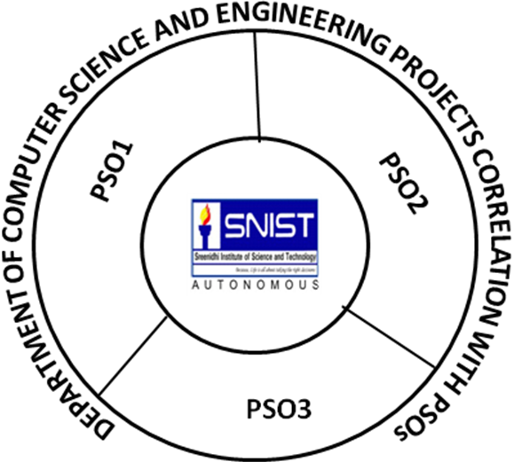

**H**

**H**

**H**

**Guide HOD**